**IT6711 – DATA MINING LABORATORY**

**IV Year VII Semester**

**SYLLABUS**

**Sub Code/ Subject:** **IT6711 DATA MINING LABORATORY OBJECTIVES:**

* The student should be made to:
* Be familiar with the algorithms of data mining,
* Be acquainted with the tools and techniques used for Knowledge Discovery in Databases.
* Be exposed to web mining and text mining

**LIST OF EXPERIMENTS:**

* 1. Creation of a Data Warehouse.
  2. Apriori Algorithm.
  3. FP-Growth Algorithm.
  4. K-means clustering.

1. One Hierarchical clustering algorithm.
   1. Bayesian Classification.
2. Decision Tree.
3. Support vector machines Classification
4. Applications of classification for web mining.
5. Case Study on Text Mining or any commercial application

**REFERENCE:**

www.cs.waikato.ac.nz/ml/weka/

**COURSE OUTCOMES:**

**At the end of the course, the student should be able to**

CO1.Use Weka tools to demonstrate data mining concepts CO2. Illustrate the algorithms of data mining

CO3. Analyze the performance of tools and techniques used for Knowledge Discovery in Databases.

CO4.Analyze various web mining and text mining Algorithms

CO5.Apply the Classification Algorithms for data mining applications CO6.Apply the Clustering Algorithms for data mining applications

**LIST OF EQUIPMENTS FOR A BATCH OF 30 STUDENTS SOFTWARE**

* Weka

**HARDWARE** Standalone desktops 30 Nos

**CONTENTS**

|  |  |  |  |
| --- | --- | --- | --- |
| **Expt.no** | **Date** | **Name of the Experiment** | **Page.no** |
| **1.** |  | Creation of a Data Warehouse. |  |
| **2.** |  | Apriori Algorithm. |  |
| **3.** |  | FP-Growth Algorithm. |  |
| **4.** |  | K-means clustering. |  |
| **5.** |  | One Hierarchical clustering algorithm. |  |
| **6.** |  | Bayesian Classification. |  |
| **7.** |  | Decision Tree. |  |
| **8.** |  | Support Vector Machines. |  |
| **9.** |  | Applications of classification for web mining. |  |
| **10.** |  | Case Study on Text Mining. |  |

|  |  |
| --- | --- |
|  |  |
| **Ex no: 1**  **Date:** | **CREATION OF A DATA WAREHOUSE** |

# AIM:

**(Using ETL Tool – E**xtract **-T**ransform**-L**oad**)**

To create a data warehouse from various .csv files using Postgrsql tool.

# WHAT IS A DATA WAREHOUSE?

Data warehouse databases are designed for query and analysis, not transactions. The data that is collected from various sources is separated into analytic and transaction workloads while enabling extraction, reporting, data mining and a number of different capabilities that transform the information into actionable, useful applications.

The main data warehouse structures listed are the basic architecture, which is a simple set up that allows end-users to directly access the data from numerous sources through the warehouse, a second architecture is a warehouse with a staging area that simplifies warehouse management and helps with cleaning and processing the data before it is loaded into the warehouse. And finally there is the architecture with both a staging area and a data mart. Data marts are used to create and maintain custom categories in organizations with specialized database designed for specific businesses, so for example if an organization had a data warehouse for sales, separate from advertising, then the data mart setup would best serve their needs. To further understand a data warehouse, it is important to look at its characteristics, which are subject orientation, integration, non-volatility, and time variance.

**Subject Oriented:** This refers to when data is giving information on a particular subject. For example, a company could use data to analyze their company‘s marketing data, and it‘s effectiveness. The devotion of a data warehouse to a specific matter is the key component of a subject-oriented warehouse.

**Integrated:** This is when data gathered from a number of disparaging sources, and then all gathered into a coherent whole. By organizing differing data into consistent formats, companies can resolve problems and inconsistencies among units of measurement and promote better results.

**Nonvolatile:** This refers to data that remains stable and unaffected by new developments. Once entered into the system, this data should not change, ensuring comparison analysis over a long period of time.

**Time Variant:** This refers to data gathered is identified with a particular time period and focuses on change over time. By using a large amount of data, spread over a long time

period, analysts can decipher patterns, and business relationships that would have otherwise been overlooked.

# DATA WAREHOUSE INTEGRATION PROCESS

The whole purpose of data mining is to facilitate business analysis. And to accomplish this, raw data must be arranged and consolidated into an information base usable by the firm. This process is referred to as ETL (Extract, Transform, & Load), which though it may seem like specified steps, is in opposition referring to a broader concept.

## EXTRACTION

This step in the process refers to removing the data from its source and making it accessible for further processing. All the needed data is retrieved without affecting the source system‘s performance, response time or locking in a negative manner. This first step in the ETL process usually involves a cleaning phase in which data quality is ensured through data unification. The rules of unification should include things such as making identifiers unique such as gender categories, phone number, and zip code conversions into standard form and validation of address fields converted into the proper format.

## TRANSFORMATION

This step applies a set of rules to change source data into similar dimensions so the same units of measurement can be used. This transformation step also joins data from a variety of sources, generates aggregates, surrogate keys and applies validation and new values.

## LOADING

The loading phase is a two-part process of disabling constraints and indexes before the load process starts and then enables them once the load is completed. In this step, the target of the load process is often a database.

## SETTING UP A DATA WAREHOUSE

The main purpose of a data warehouse is to organize large amounts of stable data to be easily retrieved and analyzed. So when setting up, care must be taken to ensure the data is rapidly accessible and easily analyzed. One way of designing this system is with the use of dimensional modeling, which allows large volumes of data to be efficiently queried and examined. Since much of the data in warehouses is stable, that is, unchanging, there is hardly a need for repetitive backup methods. Also, once new data is loaded it can be updated and backed up right away by way of, in some cases, the data preparation database, so it becomes available for easy access. There are four categories of data warehousing tools; these are extraction, table management, query management and data integrity tools. All these tools can be used in the setup and

maintenance of the best technology to manage and store the huge amounts of data a company collects, analyzes and reviews.

# COMPANY ANALYSIS

The first step, in setting up the company‘s data warehouse, is to evaluate the firm‘s objectives, For example, a growing company might set the objective to engage customers in building rapport. By examining what the company needs to do to achieve these tasks, what will need to be tracked, the key performance indicators to be noted and a numeric evaluation of the company‘s activities the company can note and evaluate where they need to get started.

# EXISTING SYSTEM ANALYSIS

By asking customers and various stakeholders pointed questions, [Business Intelligence](https://www.cleverism.com/lexicon/business-intelligence/) leaders can gather the performance information they currently have in place that is or isn‘t effective. Reports can be collected from various departments in the company, and they may even be able to collect analytical and summary reports from analysts and supervisors.

# INFORMATION MODELING OF CORE BUSINESS PROCESSES

An information model is conceptual, and allows for one to form ideas of what business processes need to be interrelating and how to get them linked. Since the data warehouse is a collection of correlating structures, creating a concept of what indicators need to be linked together to create top performance levels is a vital step in the information modeling stage. A simple way to design this model is to gather [key performance indicators](https://www.cleverism.com/lexicon/key-performance-indicators/) into fact tables and relate them to dimensions such as customers, salespeople, products and such.

# DESIGN AND TRACK

Once all those concepts are set in place, the next critical step is to move data into the warehouse structure and track where it comes from and what it relates to. In this phase of design, it is crucial to plan how to link data in the separate databases so that the information can be connected as it is loaded into the data warehouse tables. The ETL process can be pretty complex and require specialized programs with sophisticated algorithms, so the right tools have to be chosen at the right, and most cost effective price for the job. Because the data is to be tracked over time, the data will need to be available for a very long period. However the grain (atoms or make up) of the data will defer over time, but the system should be set that the differing granularity is still consistent throughout the singular data structure.

# IMPLEMENTATION OF THE PLAN

Once the plan is developed, there is a viable basis for scheduling the project. Because the project is grand, there should be phases of completion scheduled and then fit together upon

completion. With careful planning, the system can provide much-needed information on how factors work together to help the organizations activities**.**

# UPDATES

Since the data warehouse is set to retain data for long stretches at many levels of granularity and has already been set to be consistent throughout the system, in the design phase of the warehouse setup, there can be various storage plans that tie into the non-repetitive update. As an example, an IT manager could set up a week and monthly grain storage systems. In the day grain, data is stored in its original format for 2-3 years, after which it is summarized and moved to the weekly grain structure where it could remain for another 3-5 years and then finally to a monthly grain structure. This can all be set at the design phase to work with the different grains based on data age and be done automatically.

# DATA WAREHOUSE COMPONENTS

So as was the case in the design and set up phase of the warehouse, data was merged from varying sources into a single related database. And so far we have seen that the point of creating this warehouse structure is to retrieve information faster and more easily so a firm can market faster, create more revenue, improve service standards and manage industry changes.

# LOAD MANAGEMENT

Load management refers to the collection of information from varying internal and external sources and summarizing, manipulating and changing the data into a format that allows for analysis. To manage the load, raw data must be kept along with the changed versions to enable construction of different representations as needed.

# WAREHOUSE MANAGEMENT

Warehouse management is the day-by-day management of a data warehouse that ensures the information is available and effectively backed up and secure.

# QUERY MANAGEMENT

Query management allows access to the warehouse contents and may even include the tasks of separating information into various categories to be presented to different users. Users may access information through query tools or custom built applications.

# DATA WAREHOUSE BACKUP, STORAGE & TOOLS

Like any other program, data warehouses can be tedious to design create and implement, so special measures should be in place to ensure the information is not lost.

# BACKUP AND RESTORATION

An automatic system should be put in place to ensure the information is secure and that if needed data can be restored quickly and with little or no negative alterations. The first and most vital step is to ensure the original information source is backed up and then following that a

weekly backup of the entire warehouse as it could prove costly to have to recreate the entire system from scratch. The use of cold and multiplexing backup systems will ensure less need for restoration. However, a disaster recovery site should be made available for copies of all key system components. The simplest way to achieve this is using a system that automatically creates copies and sends them to the disaster site. But there are systems that can copy hybrid database systems and create the backup if that is needed as well.

# ONLINE AND OFFLINE STORAGE

Data storage should be done both online and offline to avoid overwhelming the system or having ―disk full‖ issues. With the system setup to store data in different granularity settings, one could stash older, raw data and unused or rarely used reports and multimedia offline. The implementation of hierarchical storage management (storing files automatically to a secondary source while allowing users access) is a smart move after implementing the data warehouse setup.

# STORAGE TOOLS

There are a few tools being created to rectify the storage issues that occur with data warehouses.

**Storage Manager** takes care of all the storage objects such as file systems, database, network intelligence devices and disk and tape arrays. This system also collects data about data, performs administrative duties and among other things let you see the health of your data warehouse.

**Storage Optimizer** is another product that can be used for recommendations of actions that will remove hot spots and improve online performance and reliability. It will also include actions to take for offline storage based on historical patterns.

Storage Planner enables planning for large online and offline database capacity. This program focuses on large, international databases and warehouses.

# STEPS:

**Create Data Warehouse using Postgresql tool (ETL Tool)**

1. Click Start –AllPrograms – PostgreSQL 9.3 – click **pgAdmin III**

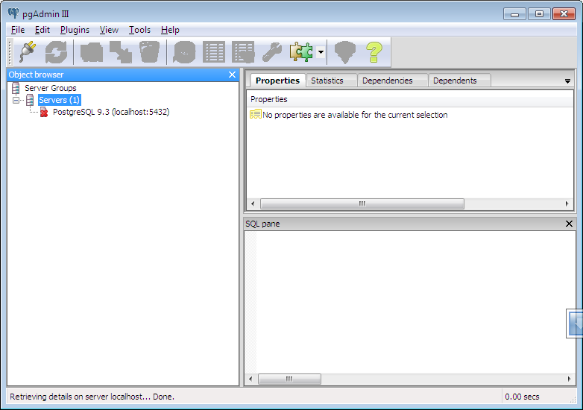

1. Click this icon 

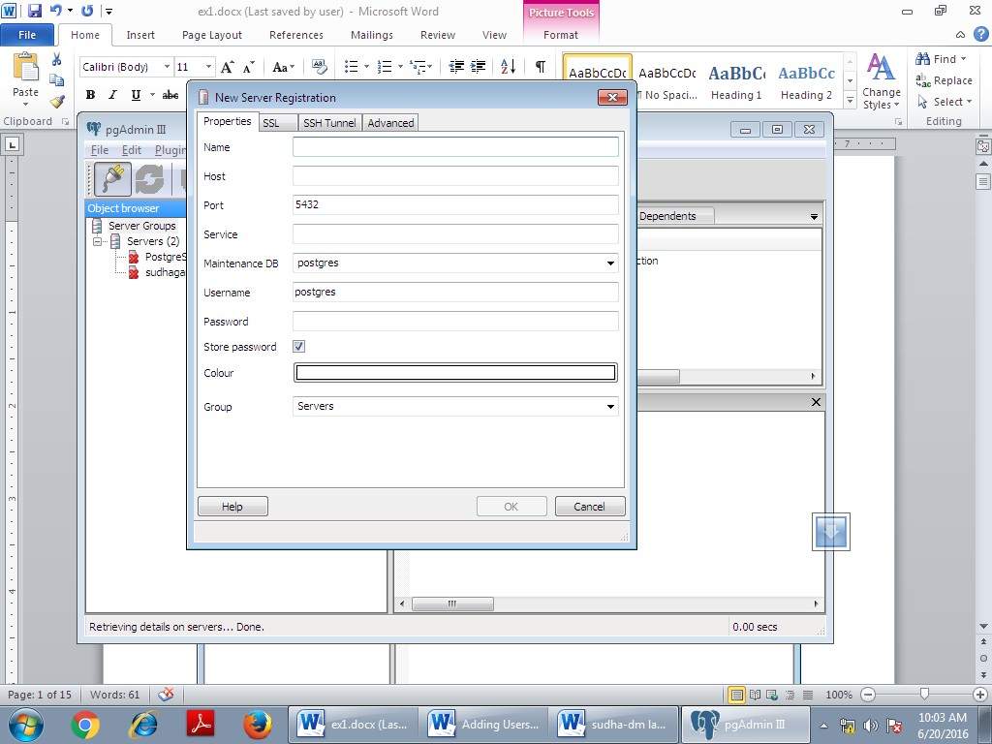

1. Enter name, host, password is **postgres**.

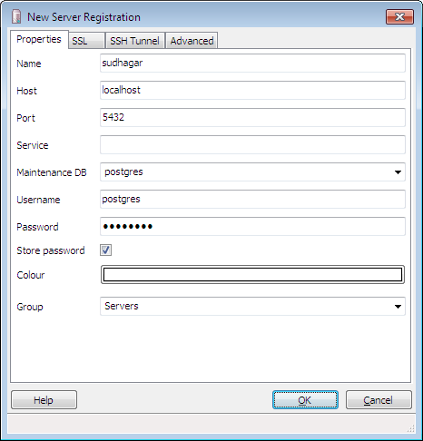

1. Double click **sudhagar(localhost:5432)**

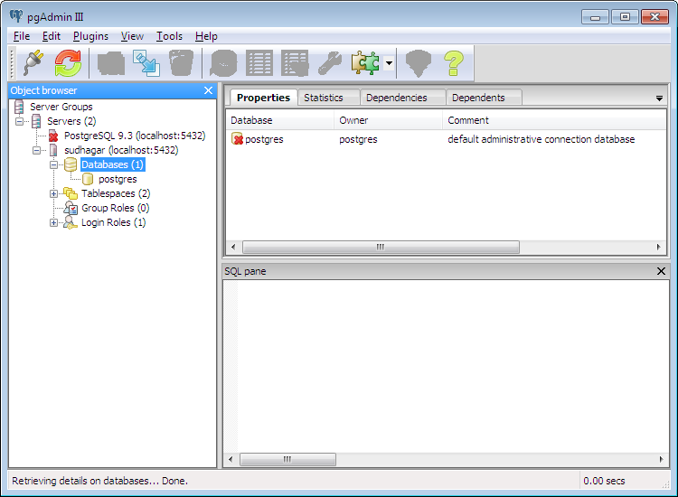

1. Right click -**databases(1)** and choose - **new database**… and type database name

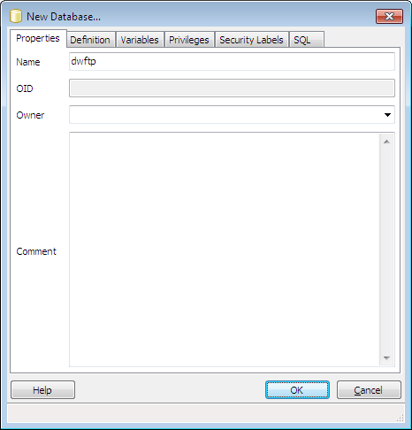

1. Double click **dwftp** and click **scemas(1)** – right click – select **new schema**… - type schema name.

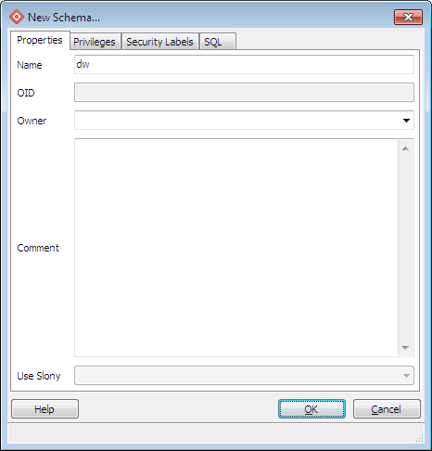

1. Double Click **dw** – **tables(0)** - Click icon – **SQL** - Type query and click **run** icon.

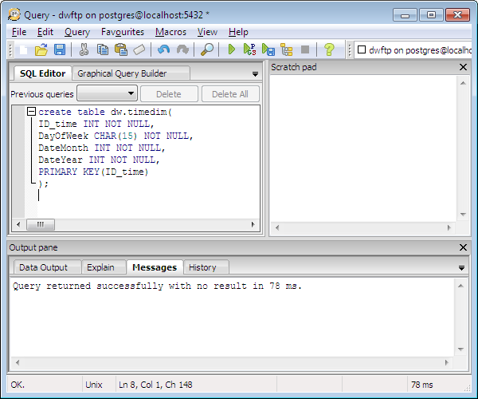

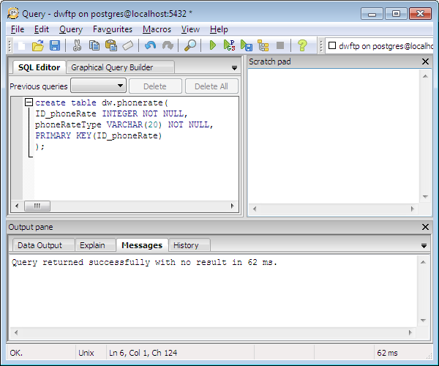

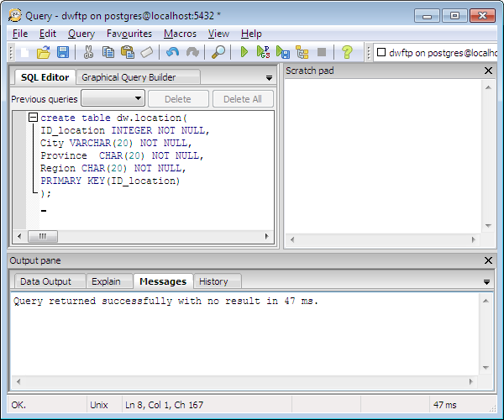

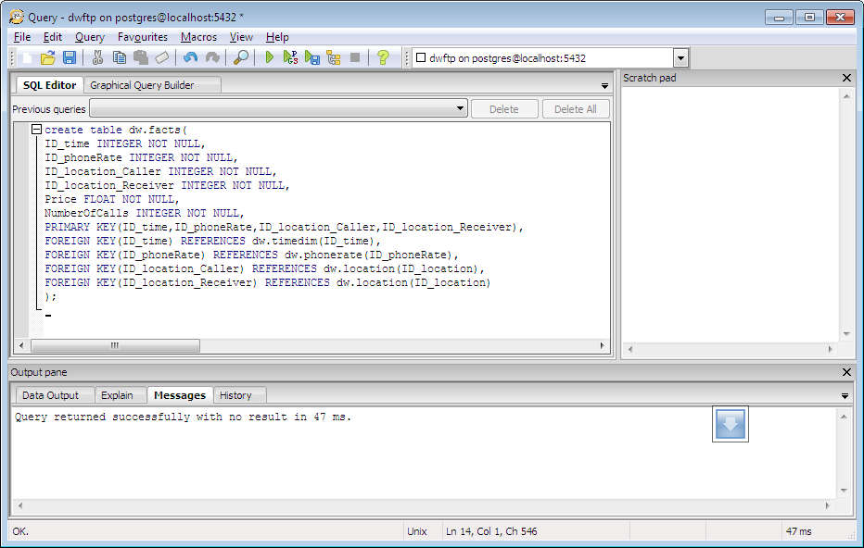

1. Then close SQL query dialog box.

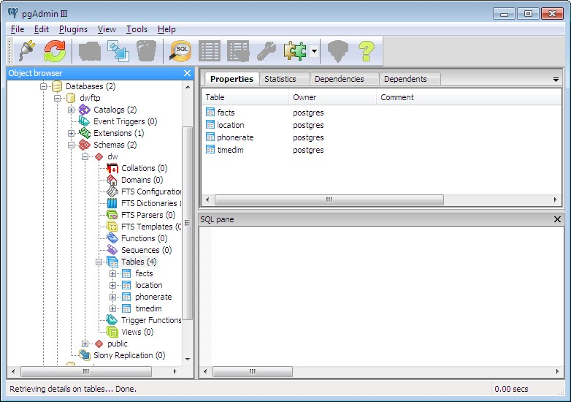

1. Upto above we created database along with primary key. Next we **Import .csv file** and store data in the databases.
   * Goto**tables** – choose table name and right click - choose **Import** option.
   * Then select .csv file from the location and select format as csv and click Import button. Now the data are stored in the databases.

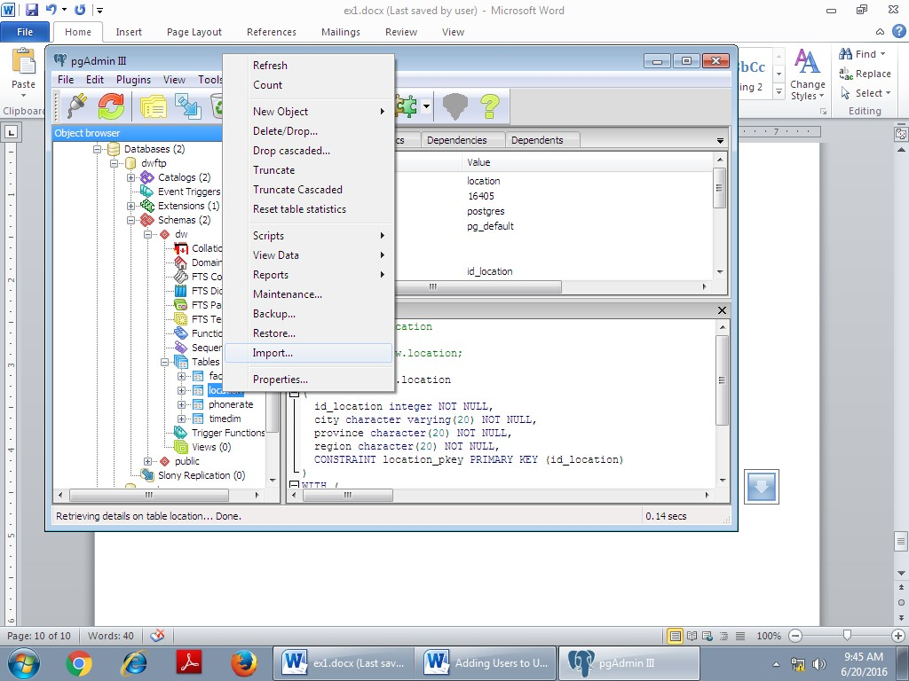

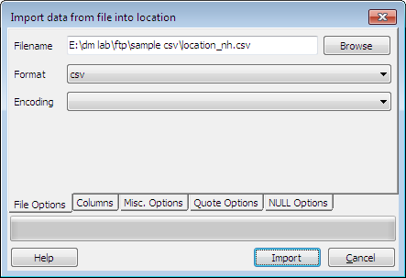

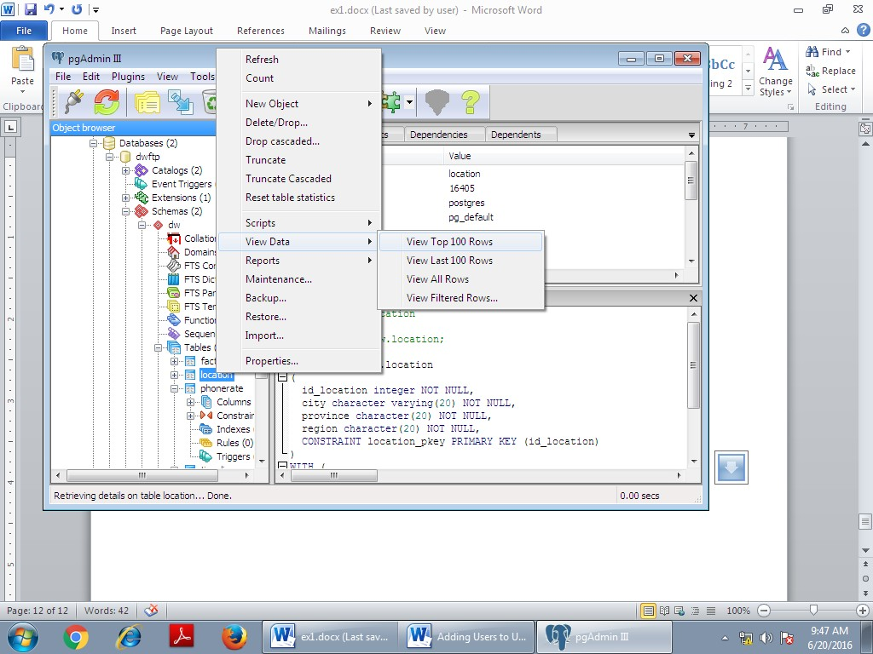

1. Similarly do the following table - phonerate, timedim and facts table.

**Display the warehouse data:**

1. Click**SQL** icon – type the queries and click **run** button.

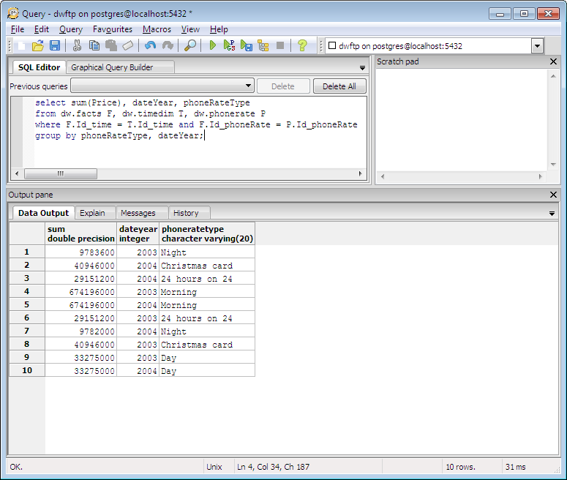

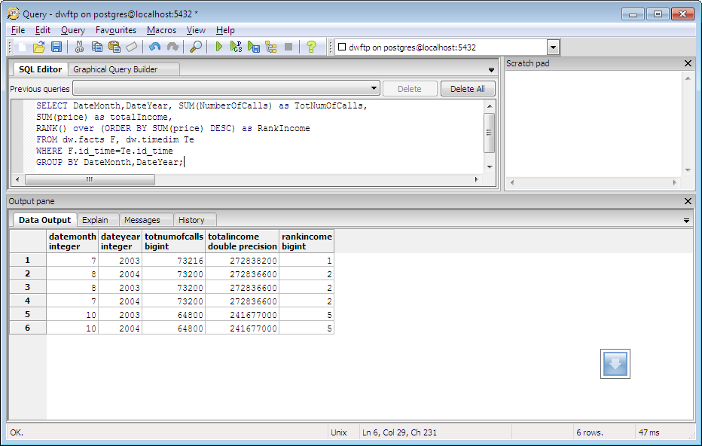

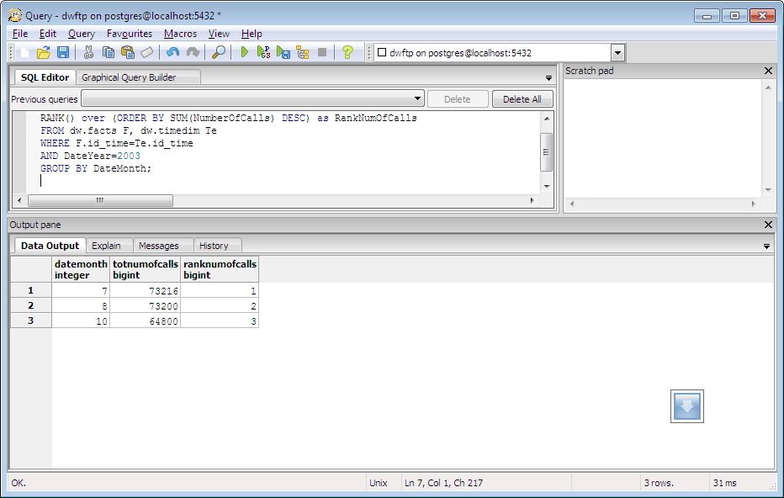

|  |  |
| --- | --- |
| **Ex no: 2 Date:** | **APRIORI ALGORITHM** |

**AIM:**

This experiment illustrates some of the basic elements of association rule mining using WEKA. The sample dataset used for this example is apriori.arff.

# INTRODUCTION

Developed by Agrawal and Srikant 1994

Innovative way to find association rules on large scale, allowing implication outcomes that consist of more than one item

Based on minimum support threshold Three versions:

1. Apriori (basic version) faster in first iterations
2. AprioriTid faster in later iteratons
3. AprioriHybrid can change from Apriori to AprioriTid after first iterations

# LIMITATIONS OF APRIORI ALGORITHM

Needs several iterations of the data Uses a minimum support threshold

Difficulties to find rarely occuring events

Alternative methods (other than appriori) can address this by using a minimum support thresold

Some competing alternative approaches focus on partition and sampling.

# PHASES OF KNOWLEDGE DISCOVERY

Data selection Data cleansing

Data enrichment (integration with additional resources) Data transformation or encoding

Data mining

Reporting and display (visualization) of the discovered knowledge

# APPLICATION OF DATA MINING

* Data mining can typically be used with transactional databases (for ex. in shopping cart analysis)
* Aim can be to build association rules about the shopping events
* Based on **item sets**, such as

{milk, cocoa powder} 2-itemset

{milk, corn flakes, bread} 3-itemset

# ASSOCIATION RULES

* Items that occur often together can be associated to each other
* These together occuring items form a **frequent itemset**
* Conclusions based on the frequent itemsets form **association rules**
* For ex. {milk, cocoa powder} can bring a rule *cocoa powderèmilk*

# SUPPORT AND CONFIDENCE

* If confidence gets a value of 100 % the rule is an **exact rule**
* Even if confidence reaches high values the rule is not useful unless the support value is high as well
* Rules that have both high confidence and support are called **strong rules**
* Some competing alternative approaches can generate useful rules even with low support values

# GENERATING ASSOCIATION RULES

* Usually consists of two sub problems:

1. Finding frequent itemsets whose occurrences exceed a predefined minimum support threshold
2. Deriving association rules from those frequent itemsets (with the constrains of minimum confidence threshold)

* These two sub problems are solved iteratively until new rules no more emerge
* The second sub problem is quite straight- forward and most of the research focus is on the first sub problem.

# USE OF APRIORI ALGORITHM

* Initial information: transactional database D and user-defined numeric minimum support threshold *min_sup*
* Algorithm uses knowledge from previous iteration phase to produce frequent itemsets
* This is reflected in the Latin origin of the name that means ‖from what comes before.

# CREATING FREQUENT SETS

* Let‘s define: Ckas a candidate itemset of size kLk as a

frequent itemset of size k

* Main steps of iteration are:

1. Find frequent set Lk-1
2. Join step: Ck is generated by joining Lk-1 with itself (Cartesian product Lk-1 x Lk-1)
3. Prune step (apriori property): Any (k − 1) size itemset that is not frequent cannot be a subset of a frequent k size itemset, hence should be removed
4. Frequent set Lk has been achieved.

Algorithm uses breadth-first search and a hash tree structure to make candidate itemsets efficiently

Then occurrence frequency for each candidate itemset is counted

Those candidate itemsets that have higher frequency than minimum support threshold are qualified to be frequent itemsets.

# APRIORI ALGORITHM IN PSEUDOCODE

L1= {frequent items};

**for**(k= 2; Lk-1!=∅; k++) **do begin**

Ck= candidates generated from Lk-1 (that is: Cartesian product Lk-1 x Lk-1 and eliminating any k-1 size itemset that is not frequent); **for each** transaction t in database **do**

increment the count of all candidates in Ck that are contained in t Lk = candidates in Ck with *min_sup*

# end

**return** kLk;

# STEPS:

1. Open **Excel** and prepare dataset and save as **apriori.csv**

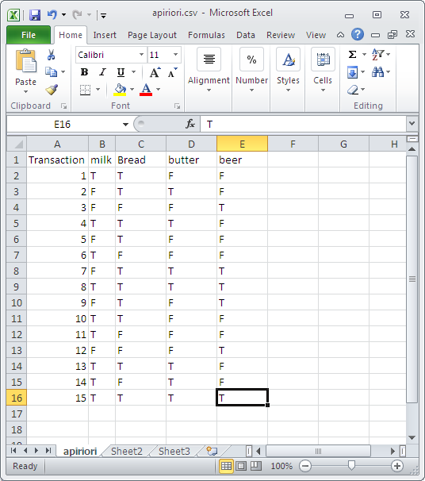

1. Open **weka** tool and click **Explorer** button.



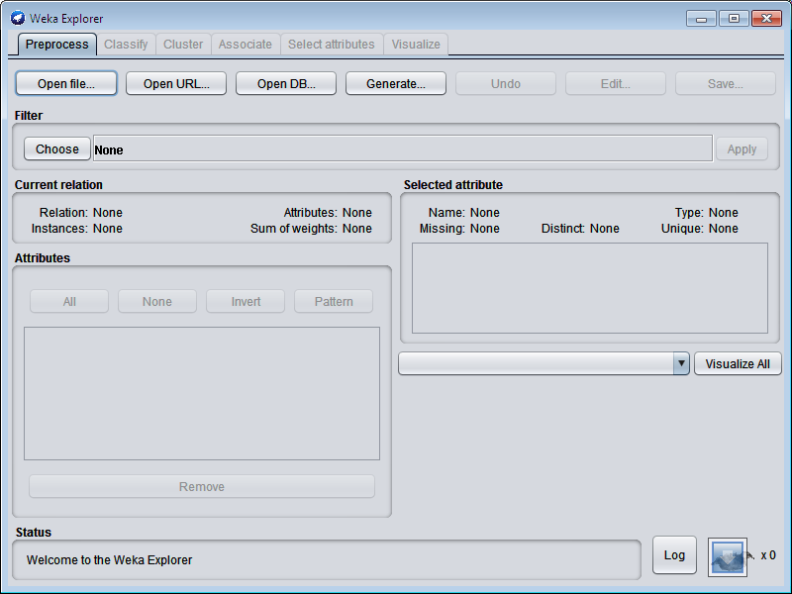

Click **open file..**button in Preprocess tab and select **apriori.csv.**

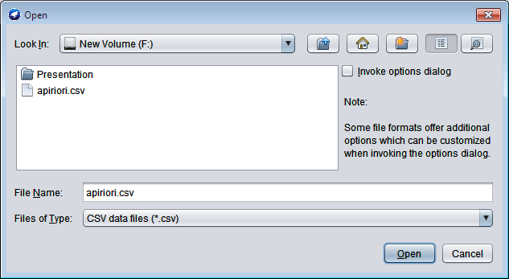

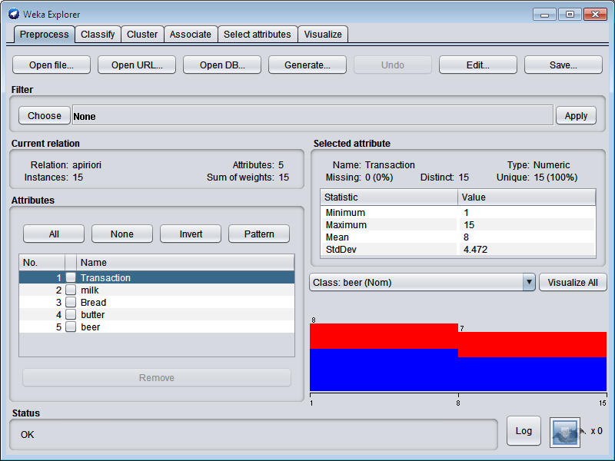

Remove- **Transaction** field and save the file as **aprioritest.arff**

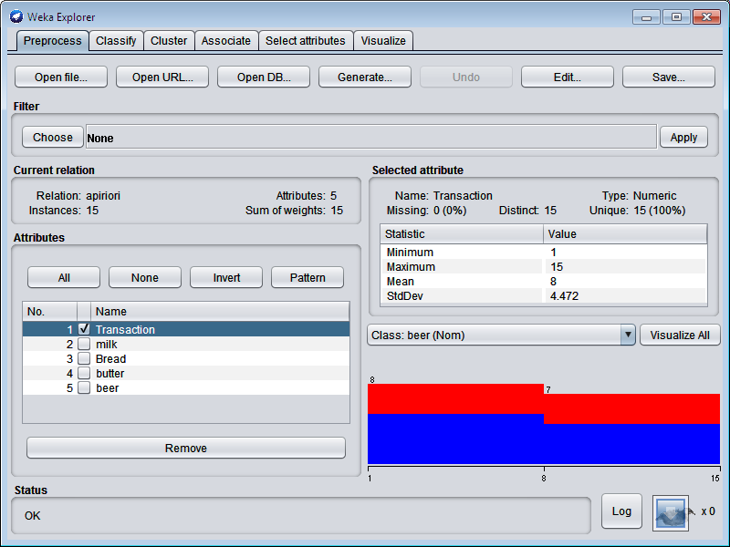

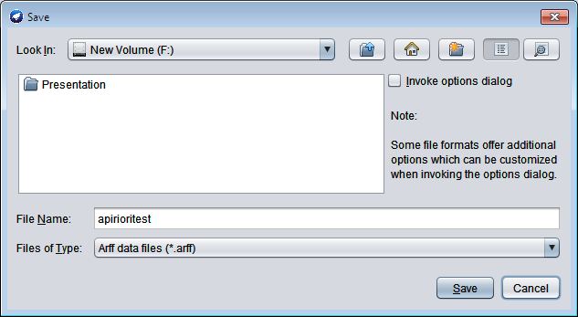

Goto **Associate** tab – choose **Apriori** and click **Start** button.

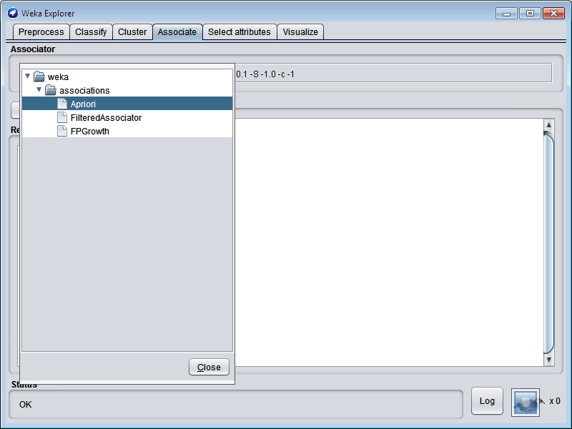

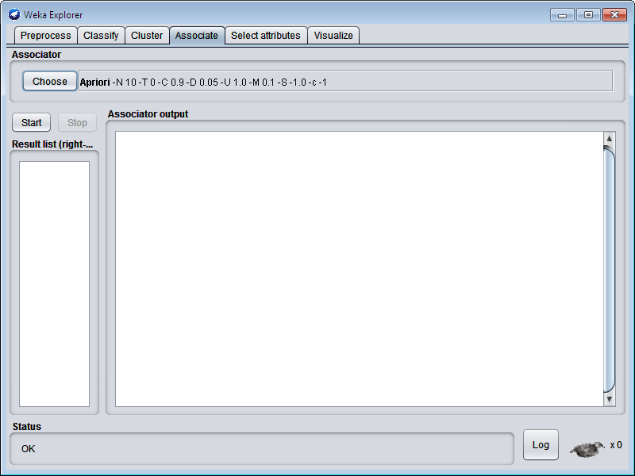

# OUTPUT:

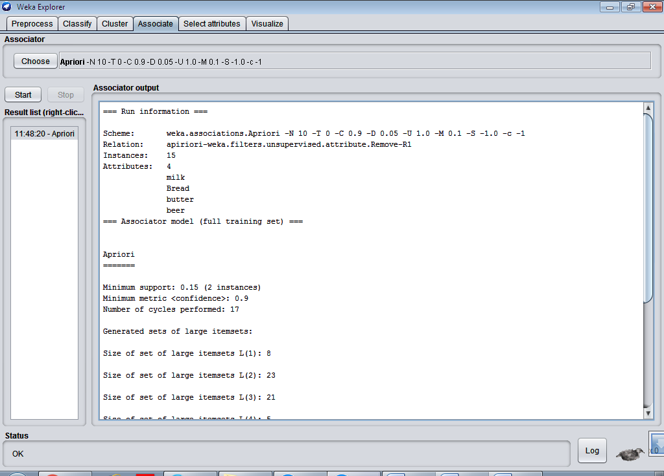

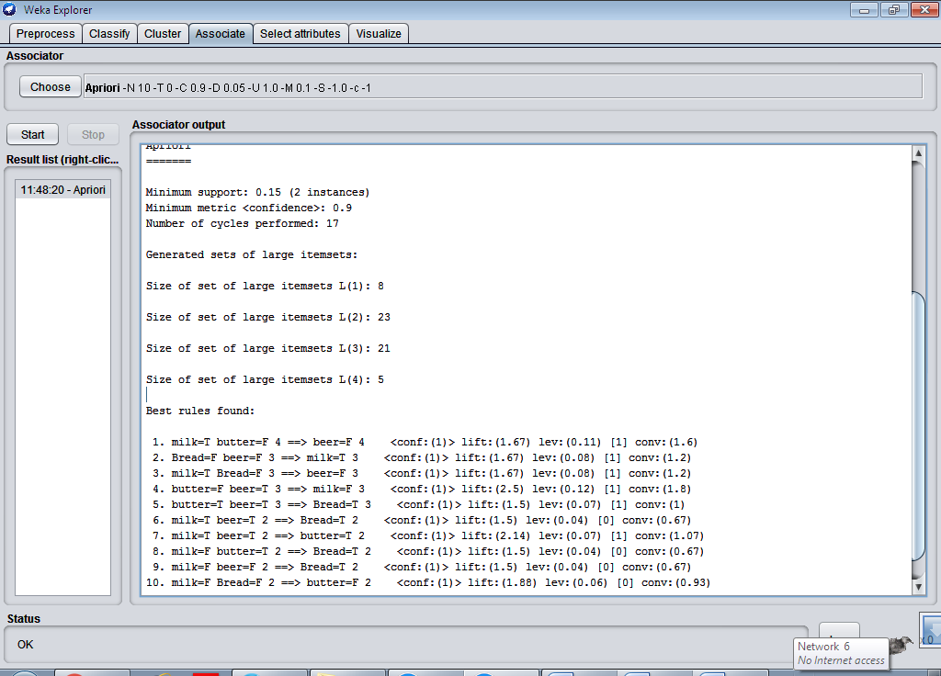

The above screenshot shows the association rules that were generated when apriori algorithm is applied on the given dataset.

|  |  |
| --- | --- |
| **Ex no: 3 Date:** | **FP GROWTH ALGORITHM** |

**AIM:**

This experiment illustrates the use of FP-Growth associate in weka. The sample data set

used in this experiment is apriori.arff. This document assumes that appropriate data preprocessing has been performed.

# INTRODUCTION

Apriori: uses a generate-and-test approach – generates candidate itemsets and tests if they are frequent.

* Generation of candidate itemsets is expensive (in both space and time)
* Support counting is expensive
  + Subset checking (computationally expensive)
  + Multiple Database scans (I/O)

FP-Growth: allows frequent itemset discovery without candidate itemset generation. Two step approach:

* Step 1: Build a compact data structure called the FP-tree. Built using 2 passes over the data-set.
* Step 2: Extracts frequent item sets directly from the FP-tree

# STEP 1: FP-TREE CONSTRUCTION

Ø FP-Tree is constructed using 2 passes over the data-set: Pass 1: Scan data and find support for each item.

Discard infrequent items.

Sort frequent items in decreasing order based on their support. Pass 2: Nodes correspond to items and have a counter

* 1. FP-Growth reads 1 transaction at a time and maps it to a path
     + Fixed order is used, so paths can overlap when transactions share items. In this case, counters are incremented
  2. Pointers are maintained between nodes containing the same item, creating singly linked lists (dotted lines)
     + The more paths that overlap, the higher the compression. FP-tree may fit in memory.
  3. Frequent itemsets extracted from the FP-Tree.

# PROCEDURE:

1. Open the data file in Weka Explorer. It is presumed that the required data fields have been discretized.
2. Clicking on the associate tab will bring up the interface for association rule algorithm.
3. We will use FP-Growth algorithm.
4. In order to change the parameters for the run (example support, confidence etc) we click on the text box immediately to the right of the choose button.

# STEPS:

1. Open **Excel** and prepare dataset and save as - **apriori.csv**



1. Open **weka** tool and click **Explorer** button.





Click **open file**..button in Preprocess tab and choose apirior.csv.





Remove- **Transaction** field and save the file as **aprioritest.arff.**





Goto **Associate** tab – choose **FPGrowth** and click **Start** button.

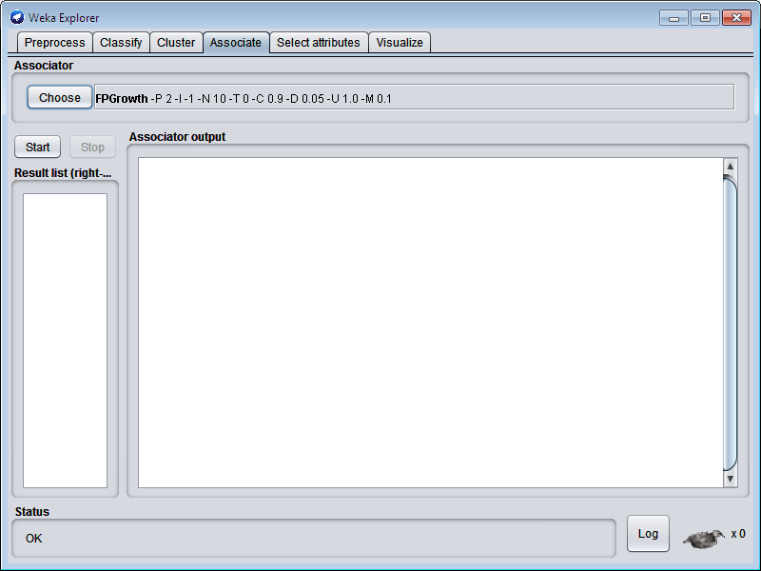

# OUTPUT:

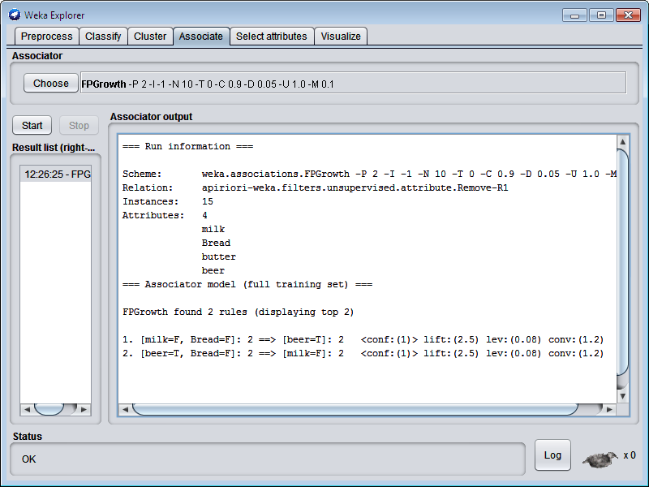

FP-Growth found 2 rules (displaying top 2)

|  |  |
| --- | --- |
| **Ex no: 4 Date:** | **K-MEANS CLUSTERING** |

**AIM:**

This experiment illustrates the use of simple k-mean clustering with Weka explorer. The

sample data set used for this example is based on the vote.arffdata set. This document assumes that appropriate pre-processing has been performed.

# WHAT IS CLUSTERING?

* + Organizing data into classes such that there is high intra-class similarity

low inter-class similarity

* + Finding the class labels and the number of classes directly from the data (in contrast to classification).
  + More informally, finding natural groupings among objects.

# EANS CLUSTERING

K-Means is simplest unsupervised learning algorithms that solve the well-known clustering problem. The procedure follows a simple and easy way to classify a given data set through a certain number of clusters (assume k clusters) fixed apriori. The main idea is to define k centers, one for each cluster. These centers should be placed in a cunning way because of different location causes different result. So, the better choice is to place them as much as possible far away from each other. The next step is to take each point belonging to a given data set and associate it to the nearest center. When no point is pending, the first step is completed and an early group age is done.

* + - The **k-means algorithm** is an algorithm to [cluster](http://en.wikipedia.org/wiki/Data_clustering) *n* objects based on attributes into

*k*[partitions](http://en.wikipedia.org/wiki/Partition_of_a_set), where *k*<*n*.

* + - It is similar to the [expectation-maximization algorithm](http://en.wikipedia.org/wiki/Expectation-maximization_algorithm) for mixtures of [Gaussians](http://en.wikipedia.org/wiki/Gaussian_distribution) in that they both attempt to find the centers of natural clusters in the data.
    - It assumes that the object attributes form a [vector space.](http://en.wikipedia.org/wiki/Vector_space)
    - Simply speaking k-means clustering is an algorithm to classify or to group the objects based on attributes/features into K number of group.
    - K is positive integer number.
    - The grouping is done by minimizing the sum of squares of distances between data and the corresponding cluster centroid.

# How the K-Mean Clustering algorithm works?

**Step 1**: Begin with a decision on the value of k = number of clusters.

**Step 2**: Put any initial partition that classifies the data into k clusters. The training samples randomly or systematically as the following:

1. Take the first k training sample as single-element clusters
2. Assign each of the remaining (N-k) training samples to the cluster

with the nearest centroid. After each assignment, recomputed the centroid of the gaining cluster. **Step 3**: Take each sample in sequence and compute its [distance](http://people.revoledu.com/kardi/tutorial/Similarity/index.html) from the centroid of each of the clusters. If a sample is not currently in the cluster with the closest centroid, switch this sample to

that cluster and update the centroid of the cluster gaining the new sample and the cluster losing

the sample.

**Step 4:** Repeat step 3 until convergence is achieved, that is until a pass throughthe training sample causes no new assignments.

# PROCEDURE:

1. Run the Weka explorer and load the data file vote.arff in preprocessing interface.
2. In order to perform clustering select the ‘cluster’ tab in the explorer and click on the choose button. This step results in a dropdown list of available clustering algorithms.
3. In this case we select ‘simple k-means’.
4. Next click in text button to the right of the choose button to get popup window shown in the screenshots. In this window we enter six on the number of clusters and we leave the value of the seed on as it is. The seed value is used in generating a random number which is used for making the internal assignments of instances of clusters.
5. Once of the option have been specified. We run the clustering algorithm there we must make sure that they are in the ‘cluster mode’ panel. The use of training set option is selected and then we click ‘start’ button. This process and resulting window are shown in the following screenshots.

**STEPS:** (Using Weka Explorer) 1.Open **weka** tool and click **Explorer.**



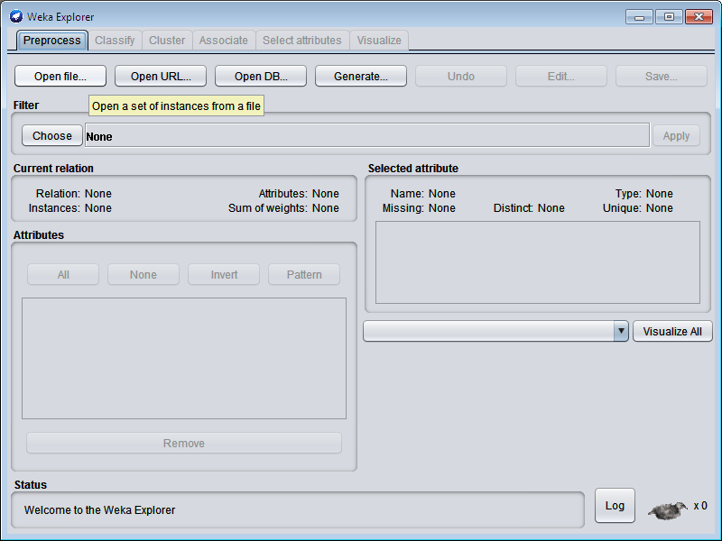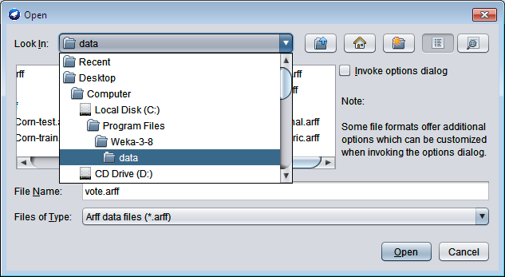2. click**Open file**…in Preprocess tab.- choose **vote.arff**

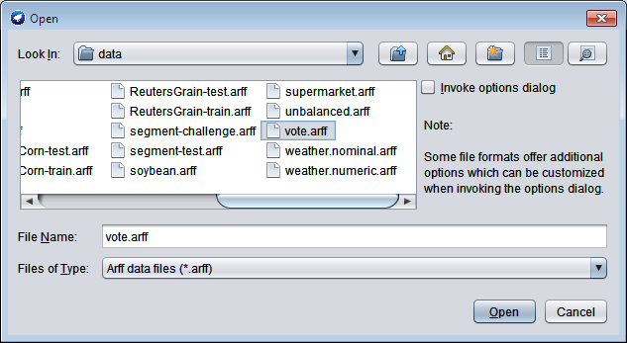

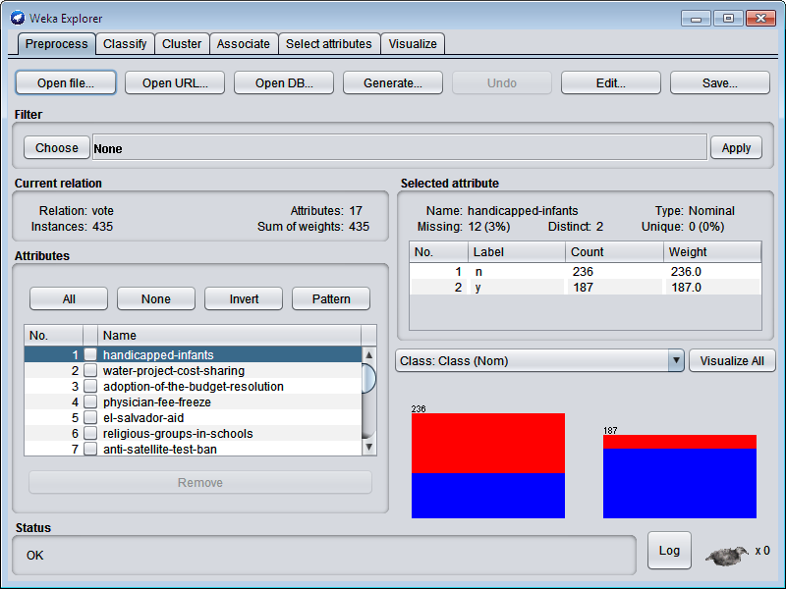

Choose **cluster** tab – click **choose** button – choose **SimpleKmeans.**

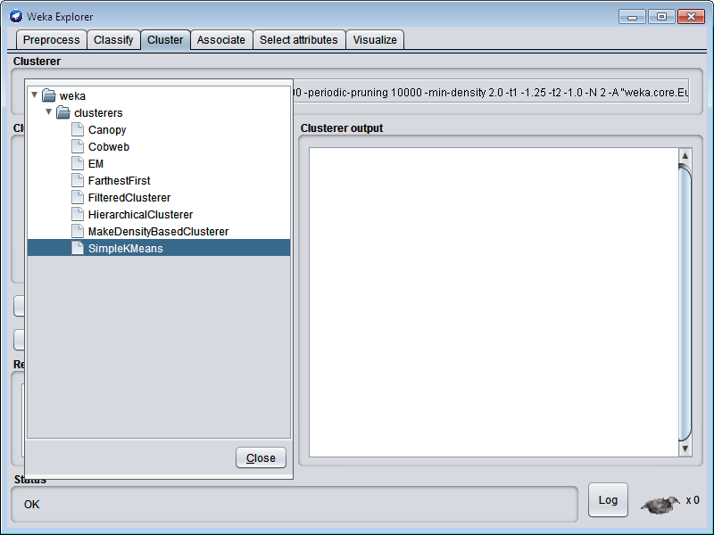

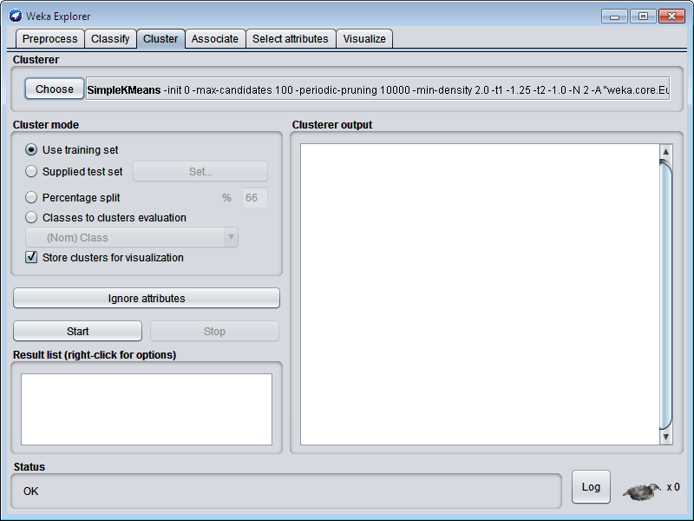

Click **Start** button.

# OUTPUT:

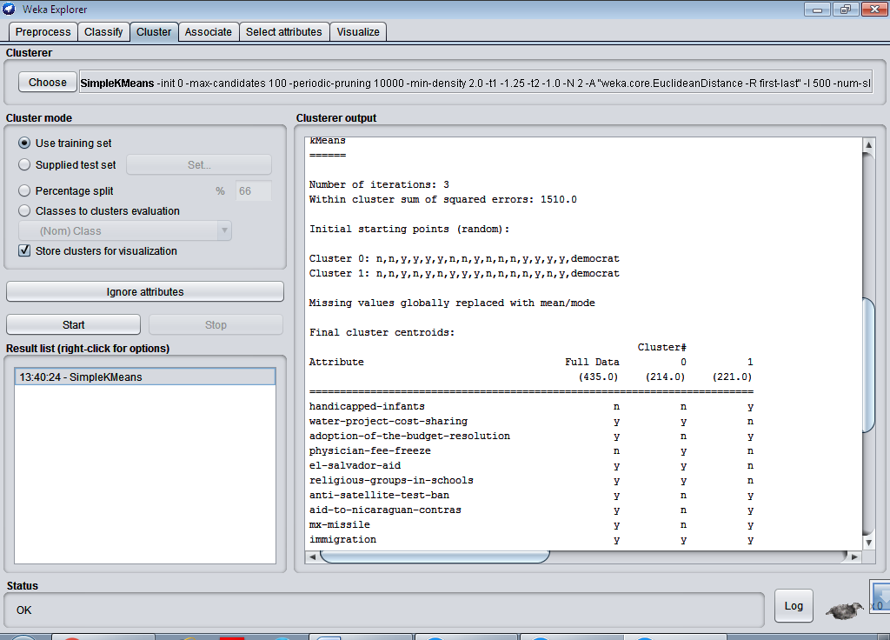

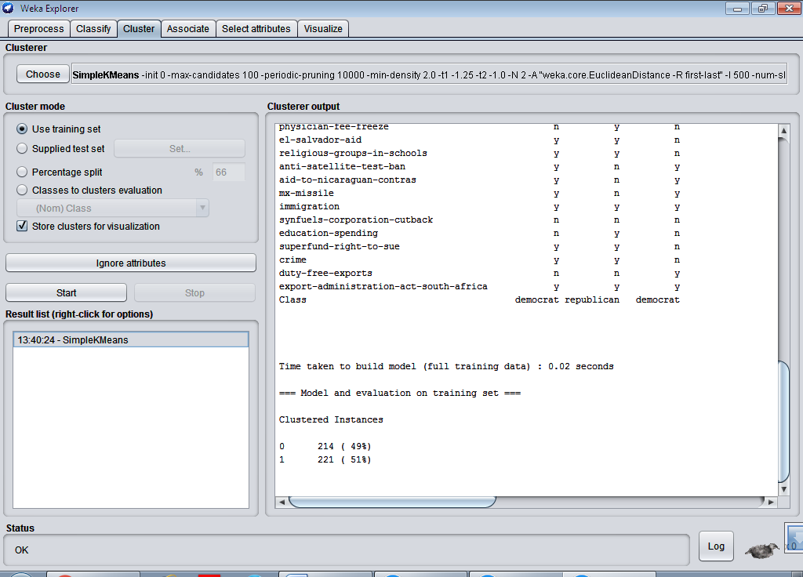

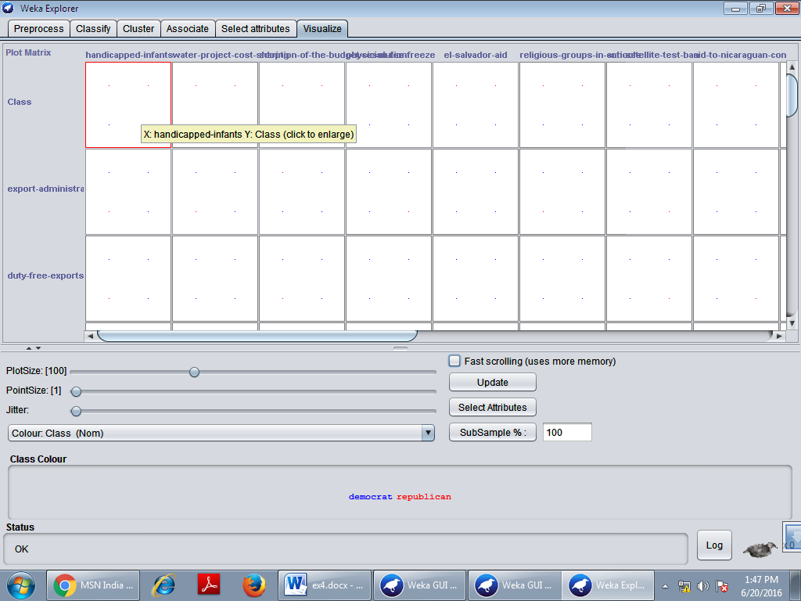Goto - **Visualize** tab- click one box any visualize.

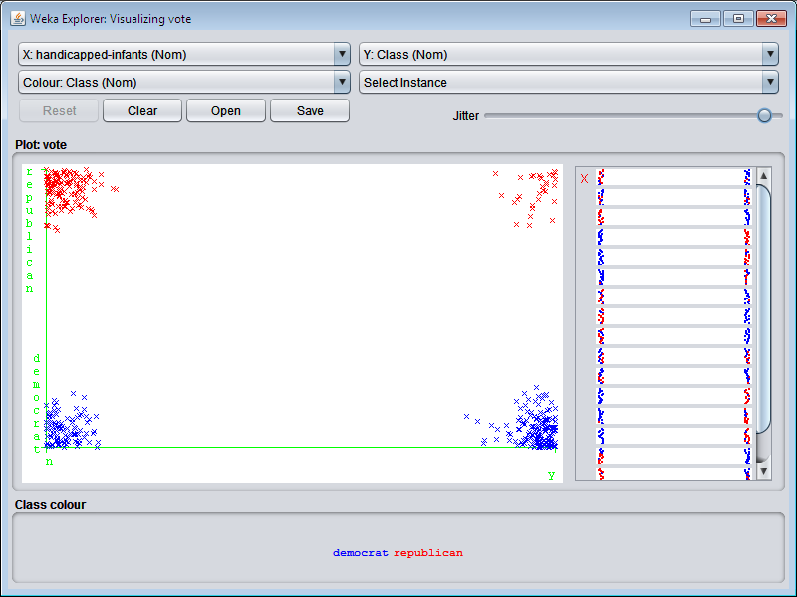

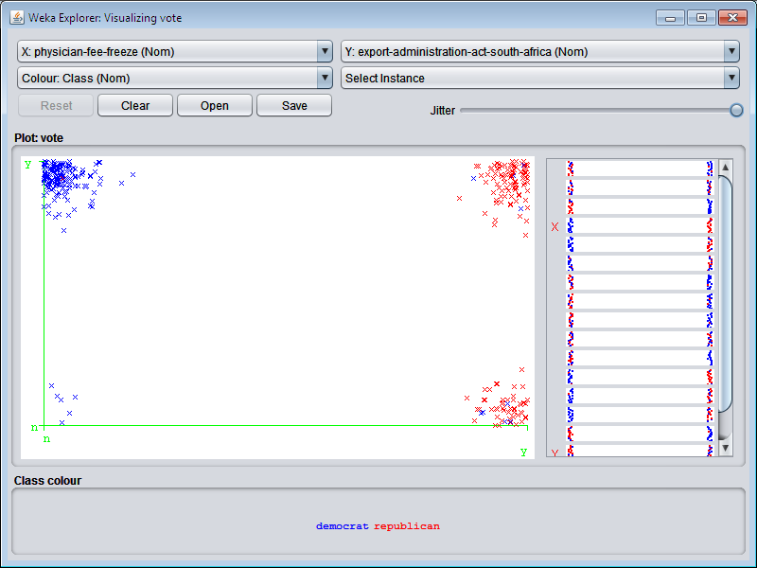

In the above move the jitter to last and to view the results of clustering.

**STEPS:** (Using WekaKnowledgeFlow) 1.Open **weka** tool and click **Explorer**.



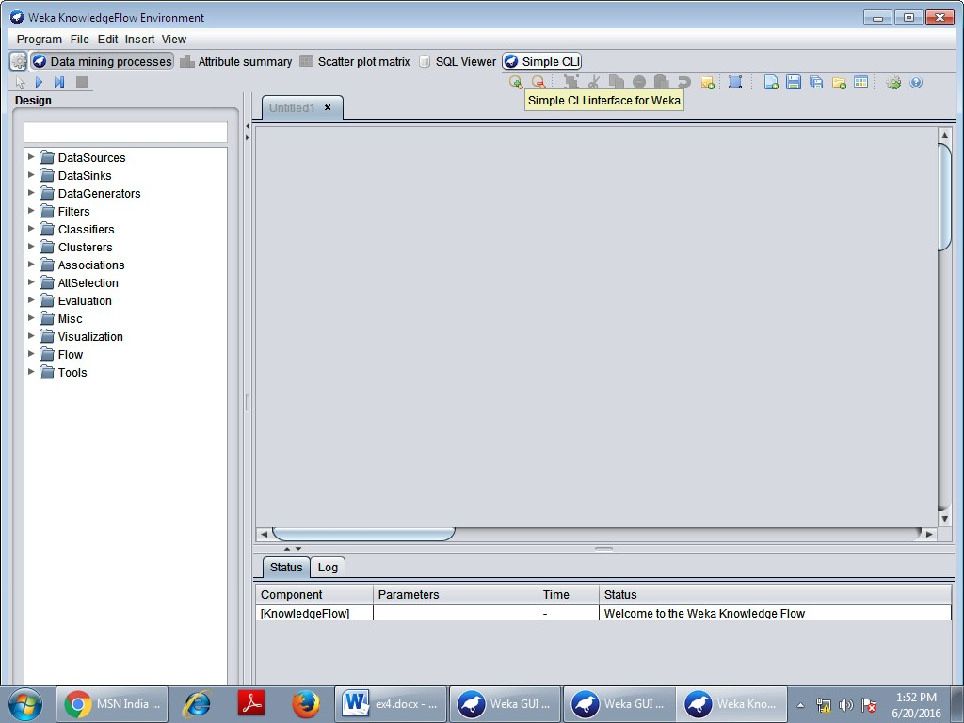

Click **DataSources** in the left side window and choose **ArffLoader** and draw in right side window.

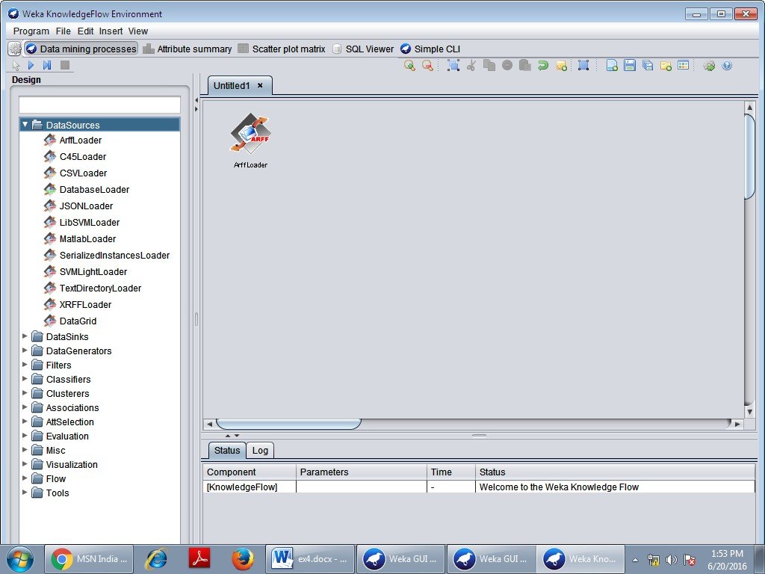

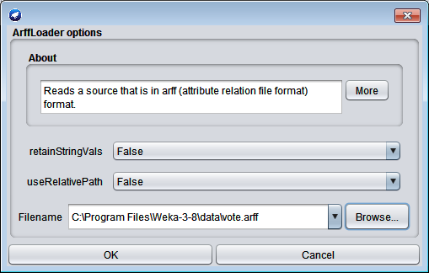Double click **ArffLoader** and choose the file name.

Similarly do the following.

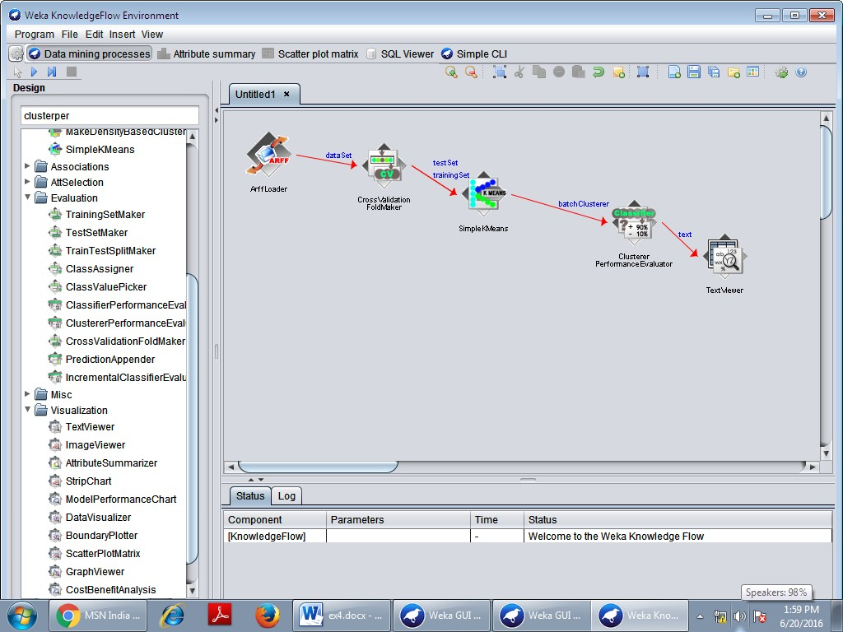

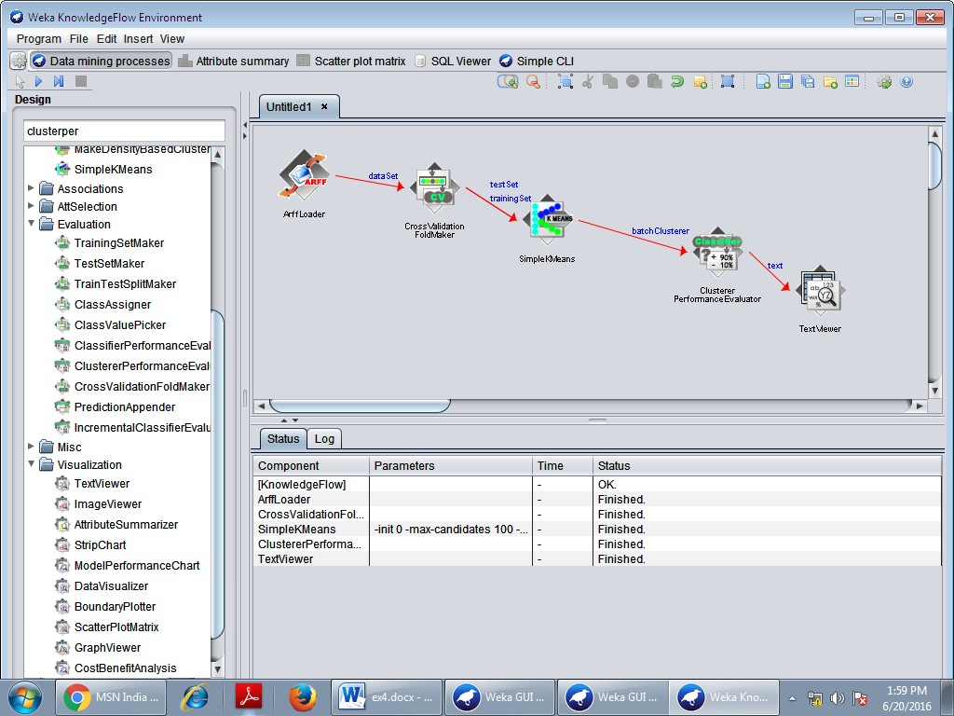Click **Run** button.

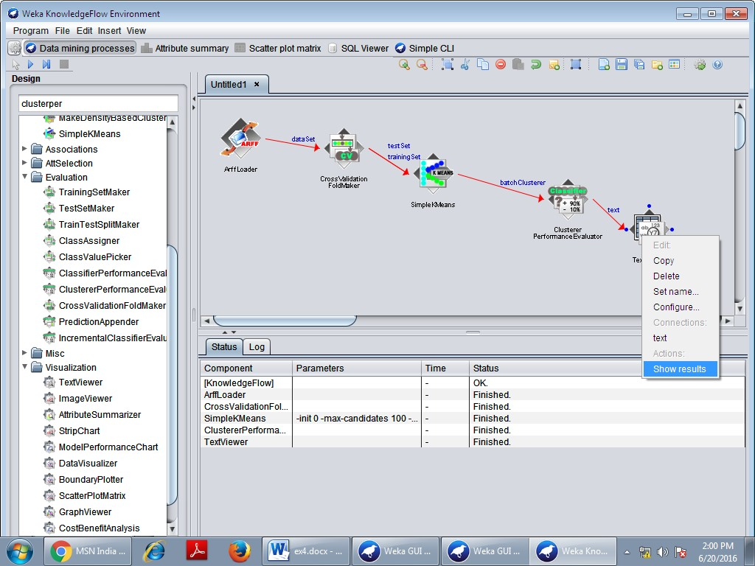Right click the **TextViwe**r choose **Show results** option.

# OUTPUT:

|  |  |
| --- | --- |
| **Ex no: 5 Date:** | **HIERARCHICAL CLUSTERING** |

**AIM:**

This experiment illustrates the use of one hierarchical clustering with Weka explorer. The

sample data set used for this example is based on the vote.arff data set. This document assumes that appropriate pre-processing has been performed.

# HIERARCHICAL CLUSTERING

Hierarchical clustering is a method of cluster analysis which seeks to build a hierarchy of clusters. Strategies for hierarchical clustering generally fall into two types. Agglomerative is a "bottom up" approach: each observation starts in its own cluster, and pairs of clusters are merged as one moves up the hierarchy. Divisive is a "top down" approach: all observations start in one cluster, and splits are performed recursively as one moves down the hierarchy.

# PROCEDURE:

1. Open the data file in Weka Explorer. It is presumed that the required data fields have been discretized.
2. Clicking on the cluster tab will bring up the interface for cluster algorithm.
3. We will use hierarchical clustering algorithm.
4. Visualization of the graph

# STEPS:

The following screenshot shows the clustering rules that were generated when hierarchical clustering algorithm is applied on the given dataset.

1. Open**Weka** tool and choose **Explorer.**



1. Click - **Open file**… in **preprocess** tab –choose **vote.arff.**

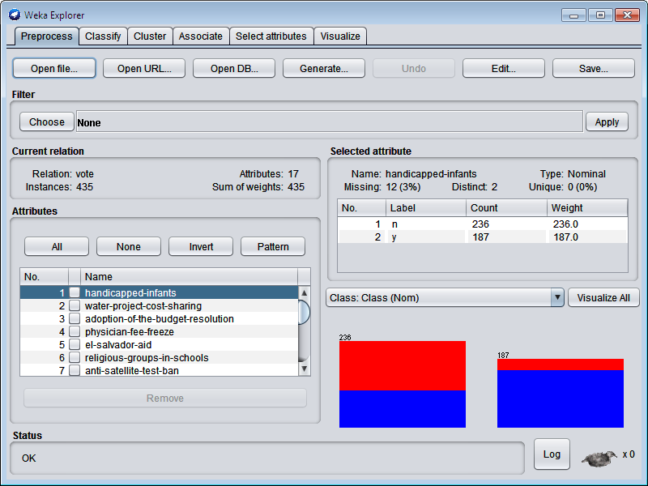

1. Goto **Cluster** tab – click **choose** button - select **HierarchicalClusterer.**

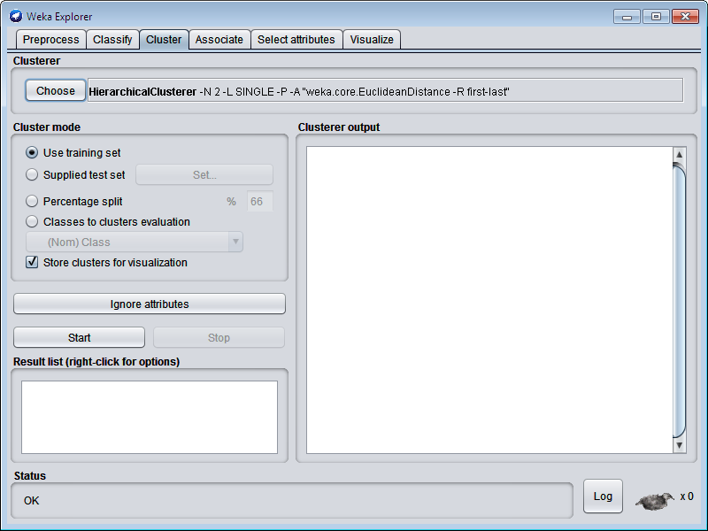

1. Click **Start** button.

# OUTPUT:

1. Visualize the tree by **right click**ing and choose **Visualize Tree** option.

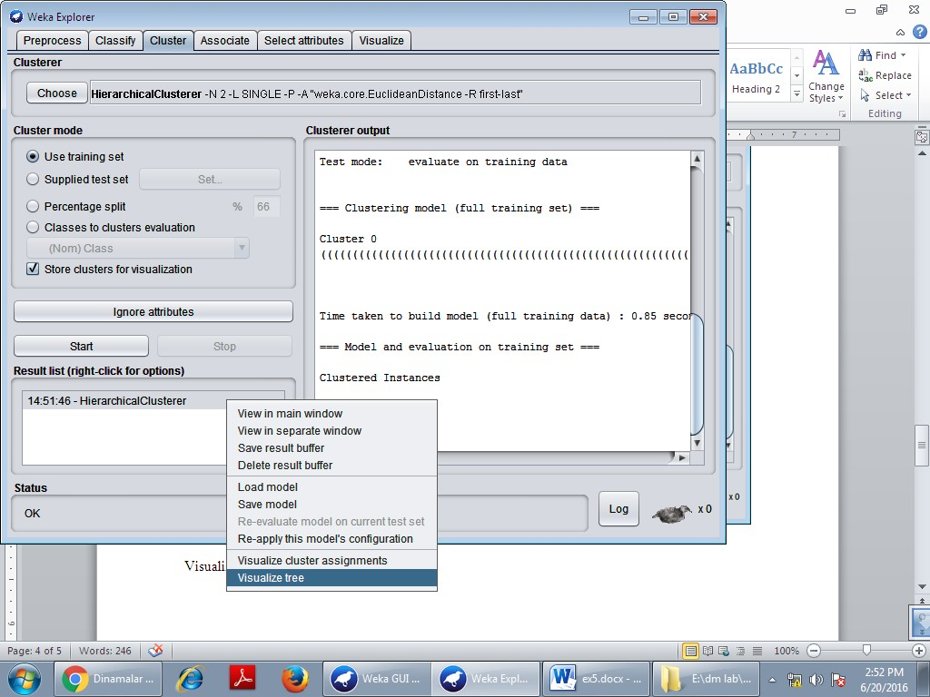

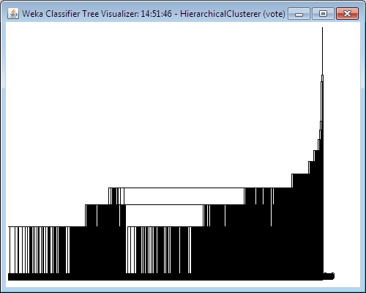

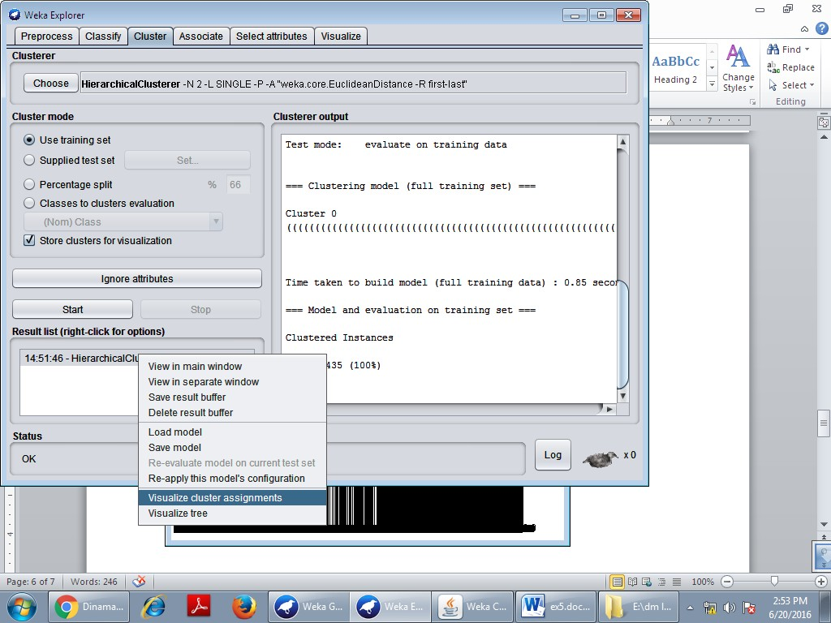

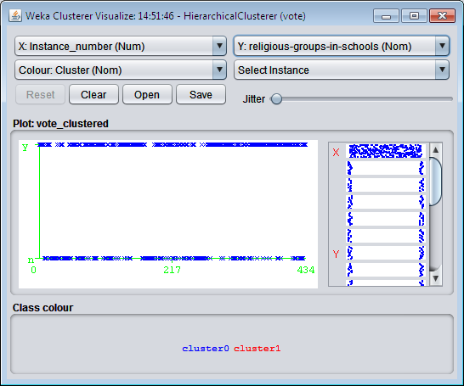

|  |  |
| --- | --- |
| **Ex no: 6 Date:** | **BAYESIAN CLASSIFICATION** |

**AIM:**

This experiment illustrates the use of Bayesian classifier with Weka explorer. The sample

data set used for this example is based on the weather.nominal.arff data set. This document assumes that appropriate pre-processing has been performed.

# BAYESIAN CLASSIFICATION

Bayesian classification is based on Bayes theorem. Bayesian classifiers are the statistical classifiers. Bayesian classifiers can predict class membership probabilities such as the probability that a given tuple belongs to a particular class.

# Bayesian Classification: Why?

A statistical classifier: performs *probabilistic prediction, i.e.,* predicts class membership probabilities

Foundation: Based on Bayes‘ Theorem.

Performance: A simple Bayesian classifier, *naïve Bayesian classifier*, has comparable performance with decision tree and selected neural network classifiers

Incremental: Each training example can incrementally increase/decrease the probability that a hypothesis is correct — prior knowledge can be combined with observed data.

Standard: Even when Bayesian methods are computationally intractable, they can provide a standard of optimal decision making against which other methods can be measured

# PROCEDURE:

1. Open the data file in Weka Explorer. It is presumed that the required data fields have been discretized.
2. Next we select the “classify” tab and click choose button to select the “NavieBayes” in the classifier.
3. Now we specify the various parameters. These can be specified by clicking in the text box to the right of the chose button. In this example, we accept the default values his default version does perform some pruning but does not perform error pruning.
4. We select the 10-fold cross validation as our evaluation approach. Since we don’t have separate evaluation data set, this is necessary to get a reasonable idea of accuracy of generated model.
5. We now click start to generate the model .the ASCII version of the tree as well as evaluation statistic will appear in the right panel when the model construction is complete.
6. Note that the classification accuracy of model is about 69%.this indicates that we may find more work. (Either in preprocessing or in selecting current parameters for the classification)
7. Now weka also lets us a view a graphical version of the classification tree.
8. We will use our model to classify the new instances.

# Bayesian Classification - For Training and Testing

## How do I divide a dataset into training and test set?

You can use the ***RemovePercentage*** filter (package weka.filters.unsupervised.instance). In the Explorer just do the following:

# Training set:

Load the full dataset

select the RemovePercentage filter in the preprocess panel set the correct percentage for the split

apply the filter

save the generated data as a new file

# Test set:

Load the full dataset (or just use undo to revert the changes to the dataset) select the RemovePercentage filter if not yet selected

set the invertSelection property to true apply the filter

save the generated data as new file

**STEPS:** (For **Weka Explorer**)

1. Open **Weka** Tool and click **Explorer** button.



# Open file in preprocess tab - weather.nominal.arff

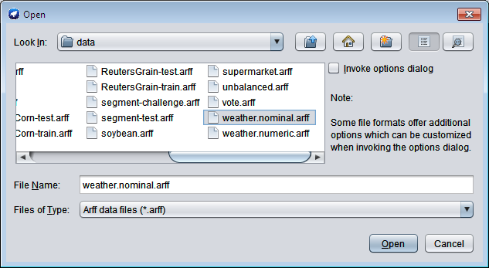

Click **Choose** button in **Preprocess** tab.

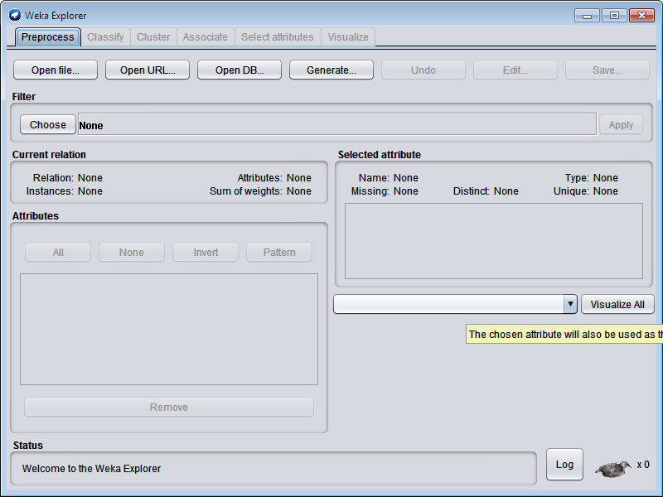

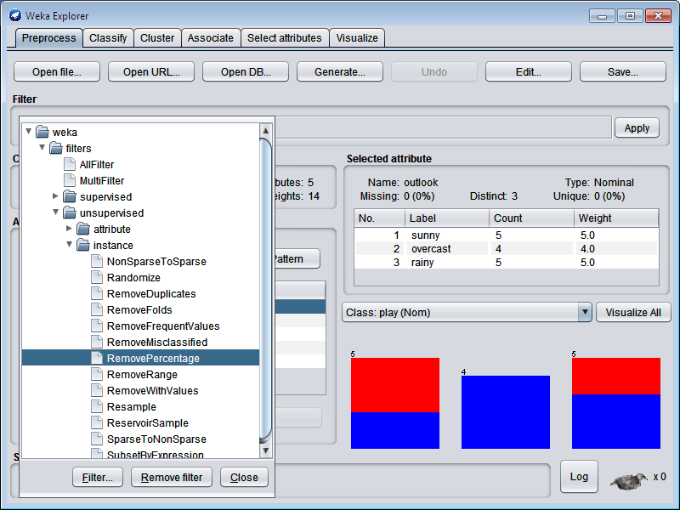

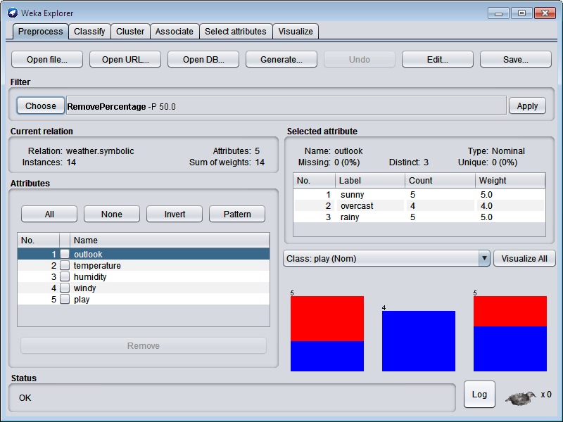

Click the above **RemovePercentage –P 50.0** and change **Percentage** as **60.0 –** click **OK.**

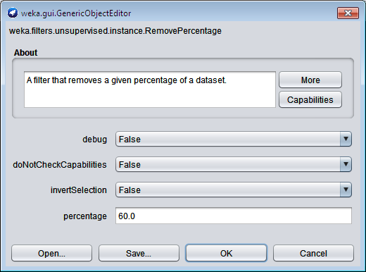

Click **Apply** and **Save –** Type file name **weather.nominaltest.arff**

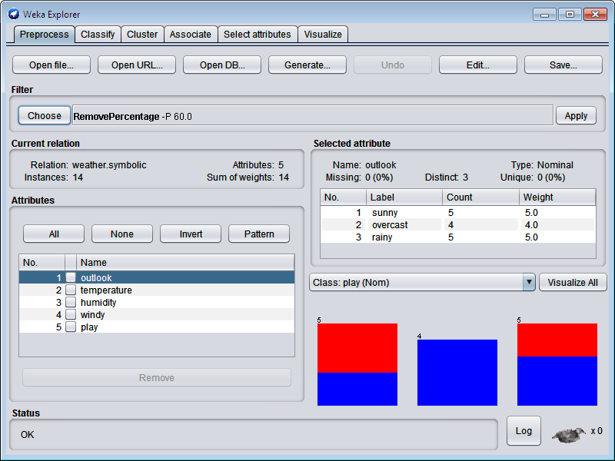

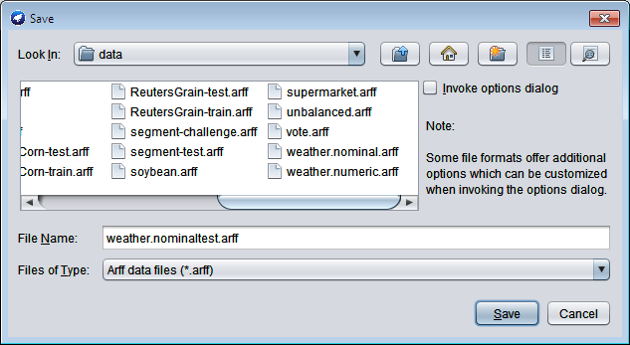

Again **open file** - **weather.nominal.arff.**



Click **Choose** button in **Preprocess** tab.







To change the **InverSelection** as **True –** click **OK.**

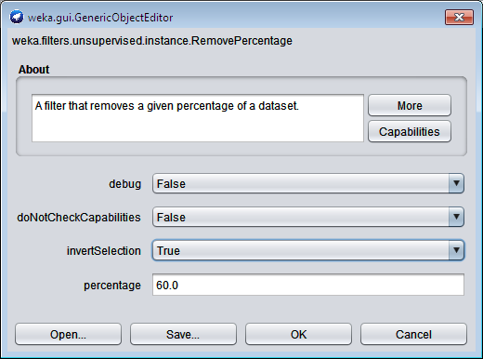

Click **Apply** and **Save –** Type file name **weather.nominaltraining.arff.**

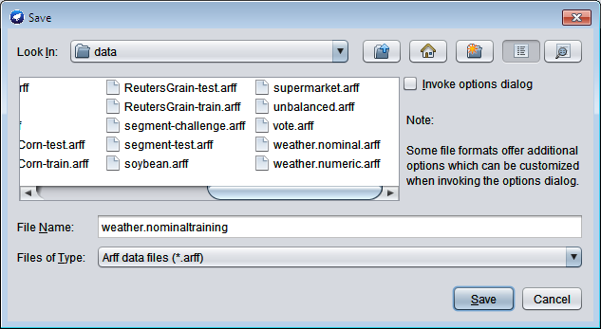

**Apply NavieBayes classification using Training set. (weather.nominaltraining.arff)**

Goto **Classify** tab in Weka Explorer and click **Choose** button- select **NavieBayes.**

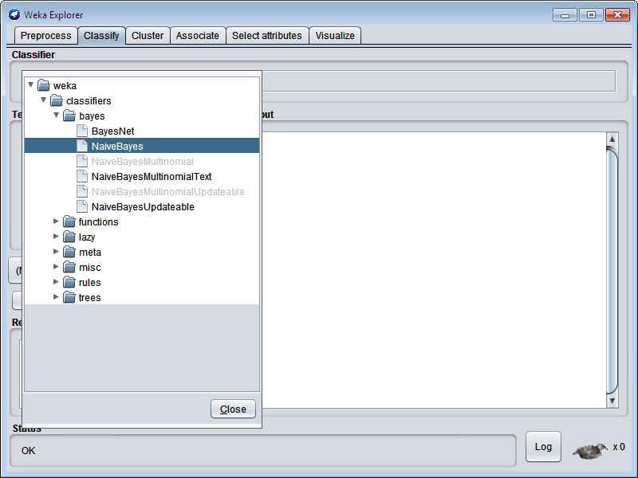

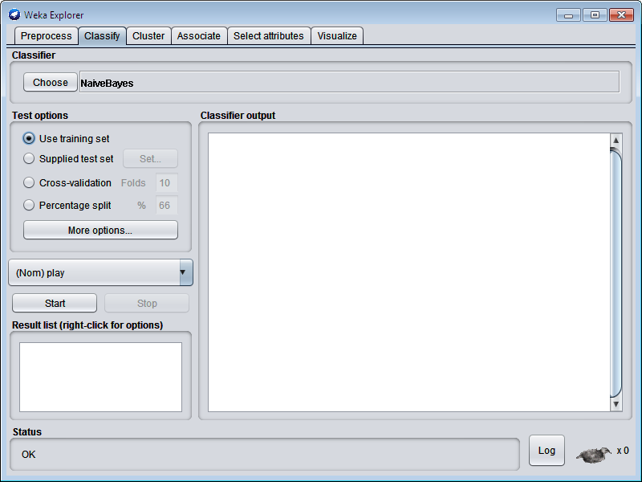

Click **Start.**

# OUTPUT:

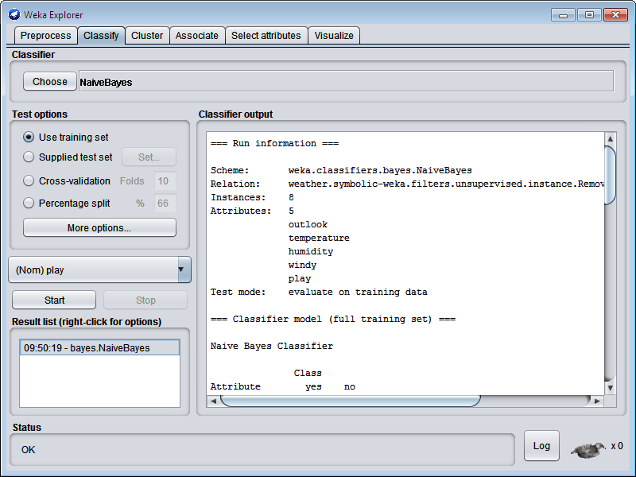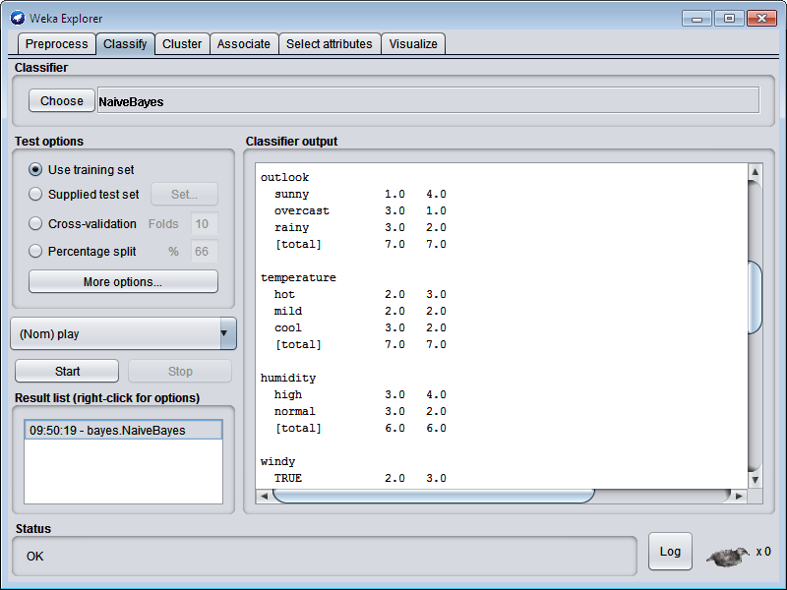

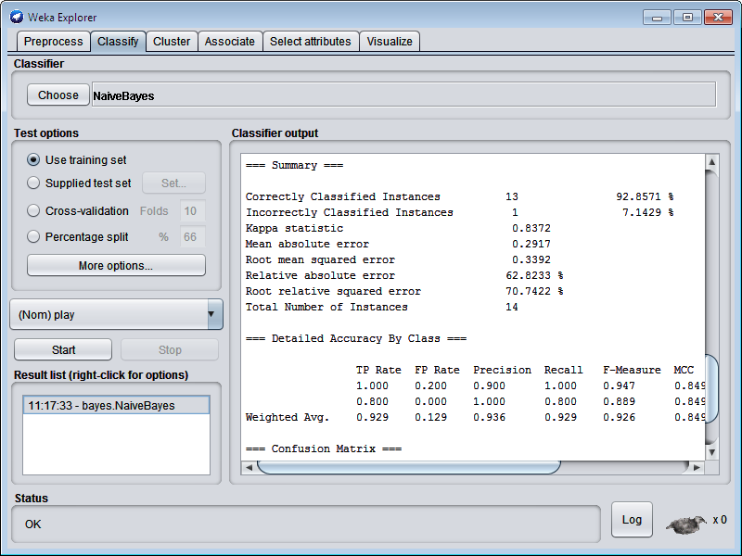

**Apply NavieBayes classification using Test set. (weather.nominaltest.arff)**

Now click **Supplied test set** – **Set** button **–** click **Open file.. –** choose **- weather.nominaltest.arff.**

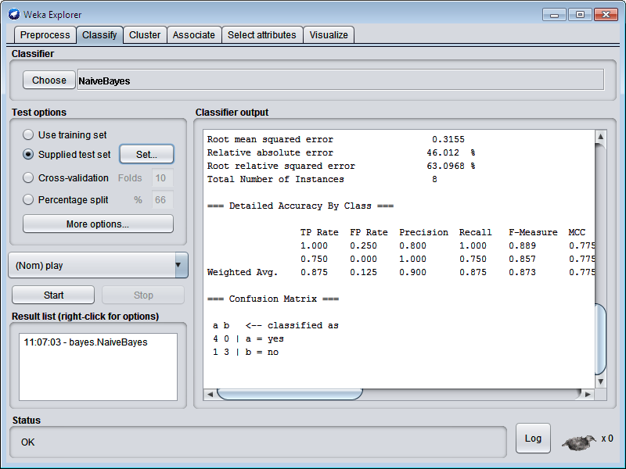

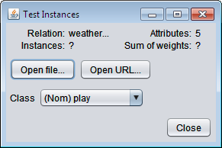

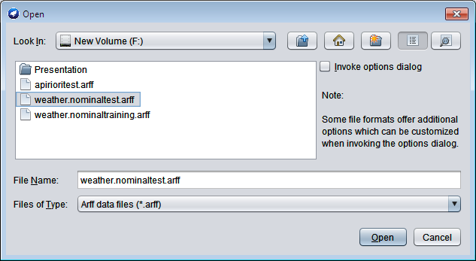

Click **Start** button.

# OUTPUT:

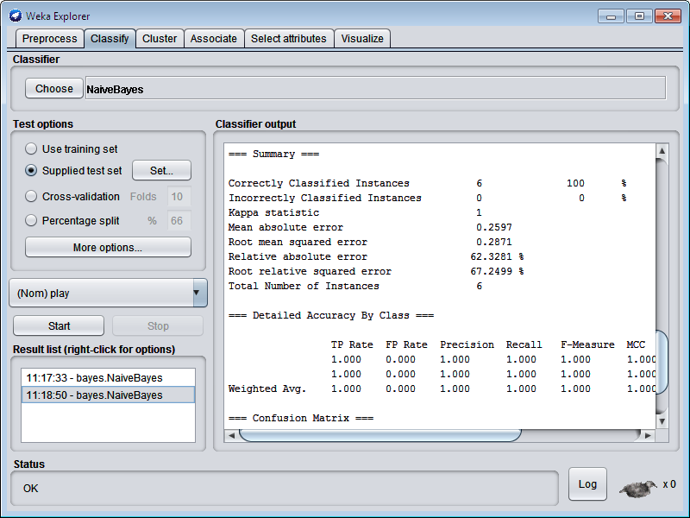

**STEPS:** (For **Knowledge Flow**)

Click **Knowledge Flow** in **Weka GUI Chooser**.



To create the following and click **Run** button and **Right click** the **TextViwer** and select **Show Result.**

Draw **ArrfLoader** and select the filename.

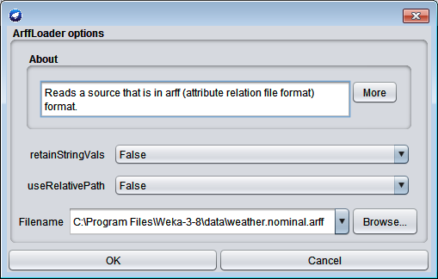

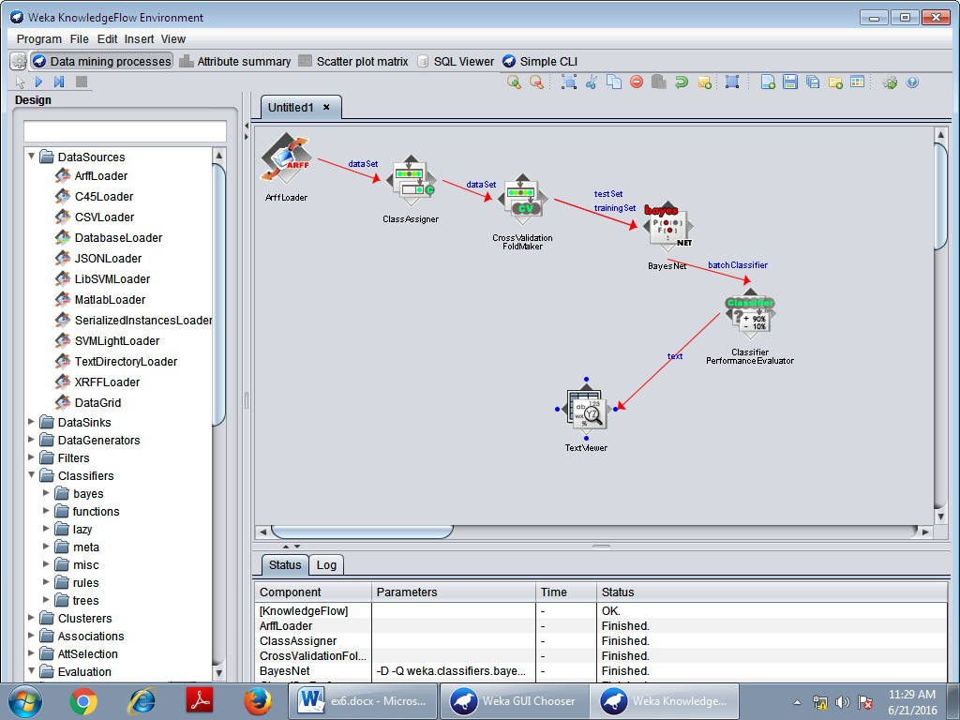

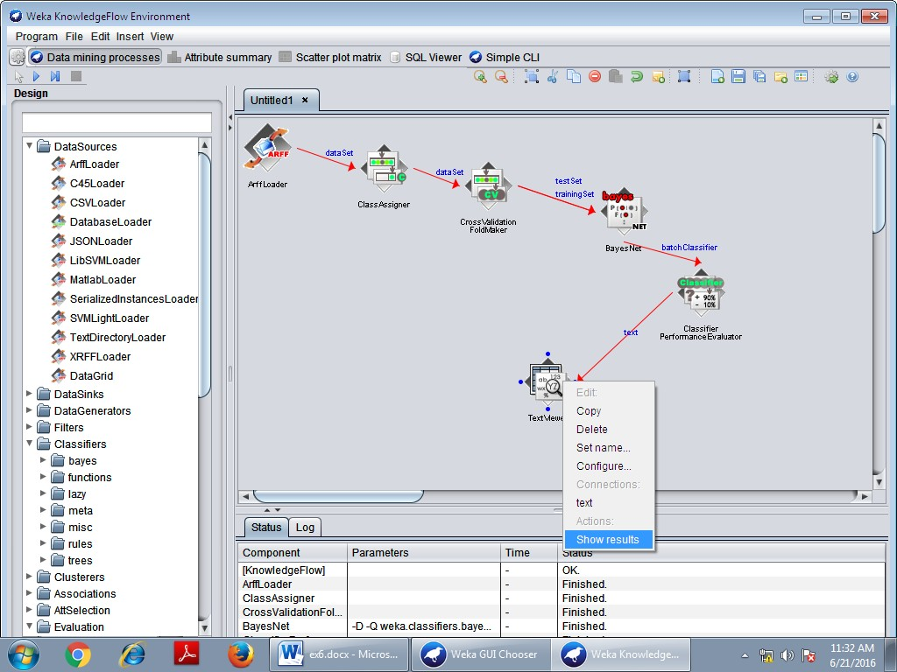

# Output:

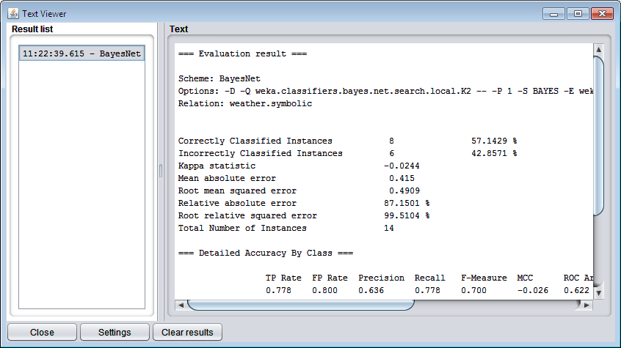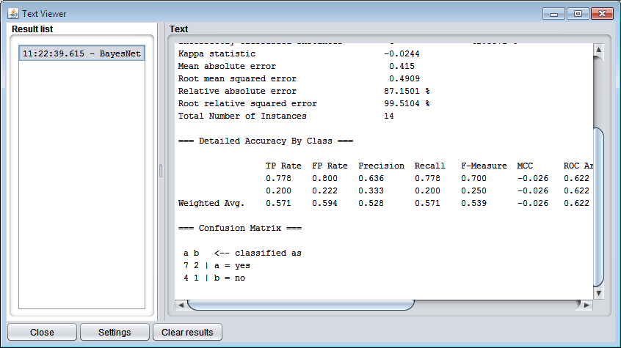

|  |  |
| --- | --- |
| **Ex no: 7 Date:** | **DECISION TREE** |

**AIM:**

This experiment illustrates the use of j-48 classifier in weka. The sample data set used in

this experiment is weather dataset available at arff format. This document assumes that appropriate data preprocessing has been performed.

# DECISION TREE

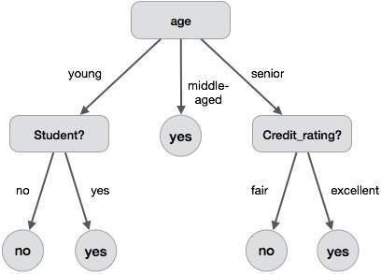A decision tree is a structure that includes a root node, branches, and leaf nodes. Each internal node denotes a test on an attribute, each branch denotes the outcome of a test, and each leaf node holds a class label. The topmost node in the tree is the root node. The following decision tree is for the concept buy computer that indicates whether a customer at a company is likely to buy a computer or not. Each internal node represents a test on an attribute. Each leaf node represents a class.

# The benefits of having a decision tree are as follows

* + It does not require any domain knowledge.
  + It is easy to comprehend.
  + The learning and classification steps of a decision tree are simple and fast.

# Decision Tree Induction Algorithm

A machine researcher named J. Ross Quinlan in 1980 developed a decision tree algorithm known as ID3 (Iterative Dichotomiser). Later, he presented C4.5, which was the successor of ID3. ID3 and C4.5 adopt a greedy approach. In this algorithm, there is no backtracking; the trees are constructed in a top-down recursive divide-and-conquer manner.

**Algorithm :Generate_decision_tree**

**Input:**

* + Data partition, D, which is a set of training tuples and their associated class labels.
  + attribute_list, the set of candidate attributes.
  + Attribute selection method, a procedure to determine the splitting criterion that best partitions that the data tuples into individual classes.
  + This criterion includes a splitting_attribute and either a splitting point or splitting subset.

# Output:

A Decision Tree

**Method**

Create a node N;

if tuples in D are all of the same class, C then return N as leaf node labeled with class C;

if attribute_list is empty then

return N as leaf node with labeled with majority class in D;|| majority voting applyattribute_selection_method(D, attribute_list)

to find the best splitting_criterion; label node N with splitting_criterion;

if splitting_attribute is discrete-valued and

multiway splits allowed then **// no restricted to binary trees** attribute_list = splitting attribute; **// remove splitting attribute** for each outcome j of splitting criterion

# // partition the tuples and grow subtrees for each partition

Let Dj be the set of data tuples in D satisfying outcome j; **// a partition**

If Dj is empty then

attach a leaf labeled with the majority class in D to node N;

else

end for

attach the node returned by Generate decision tree(Dj, attribute list) to node N;

return N;

**Tree Pruning**

Tree pruning is performed in order to remove anomalies in the training data due to noise or outliers. The pruned trees are smaller and less complex.

# Tree Pruning Approaches

Here is the Tree Pruning Approaches listed below –

* **Pre-pruning** − the tree is pruned by halting its construction early.
* **Post-pruning** - This approach removes a sub-tree from a fully grown tree.

**STEPS: (Using Weka Explorer)**

1. Open **Weka** tool and choose **Explorer.**



1. Click - **Open file**… in **preprocess** tab –choose **weather.nominal.arff.**

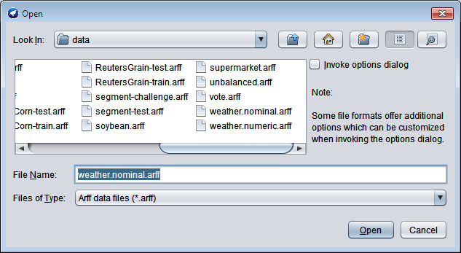

1. Goto **Classify** tab – click **choose** button – selelct **J48.**

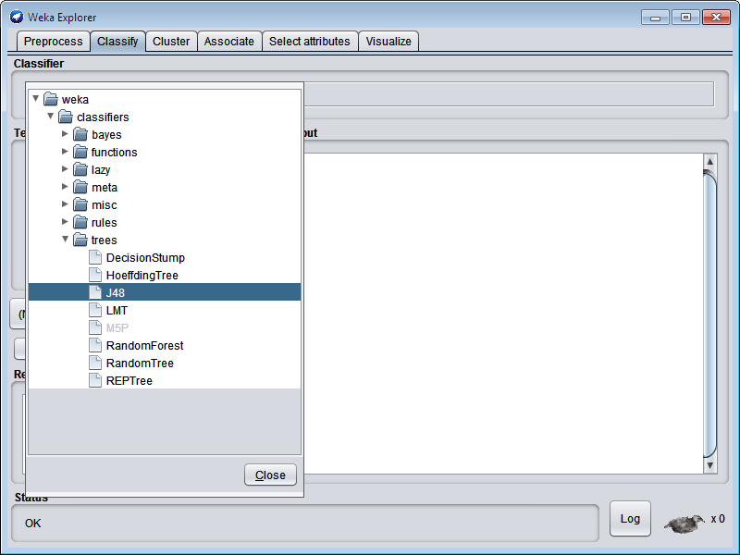

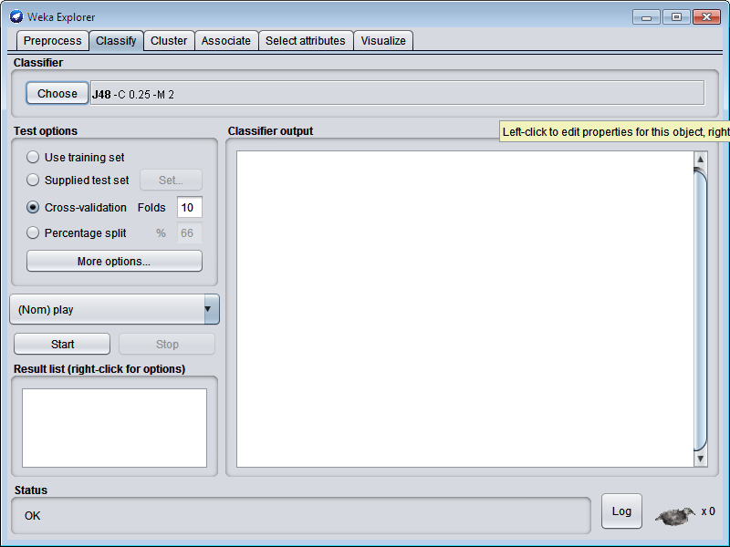

Click – **Start** button.

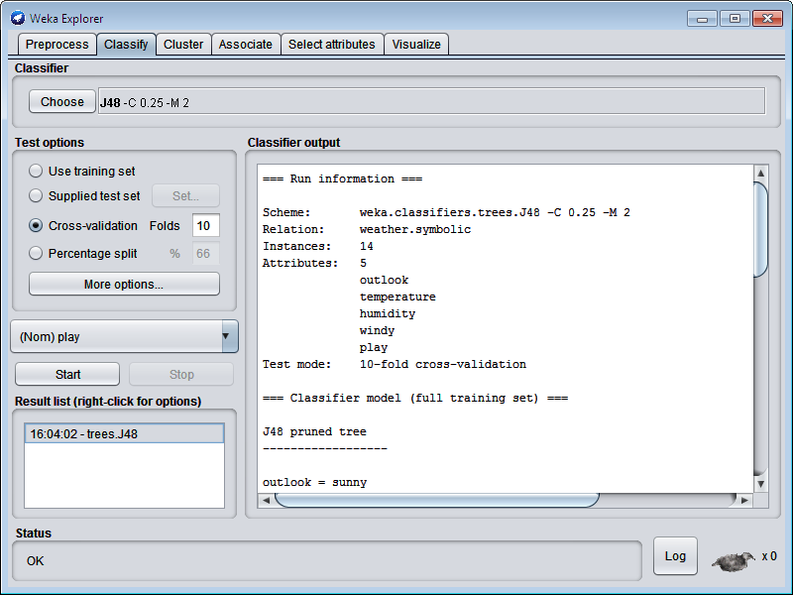

Right click **trees-J48** – choose **Visualize Tree** option.

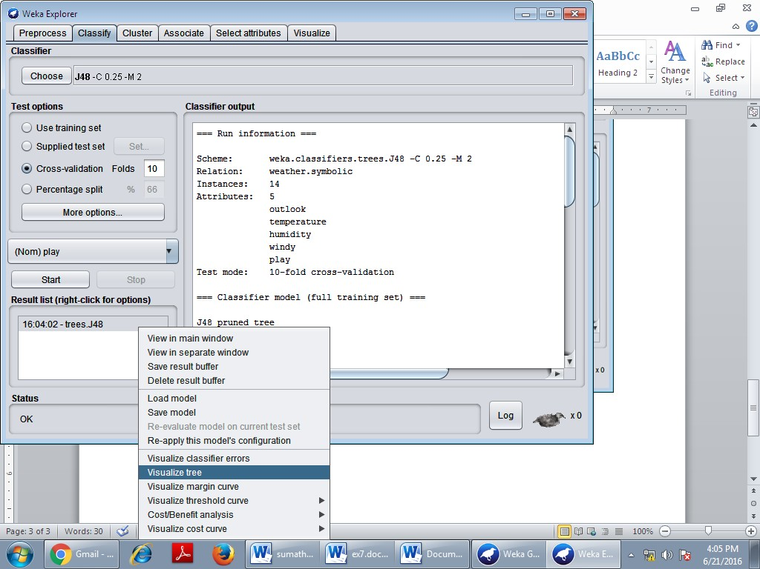

# OUTPUT :

Decision Tree

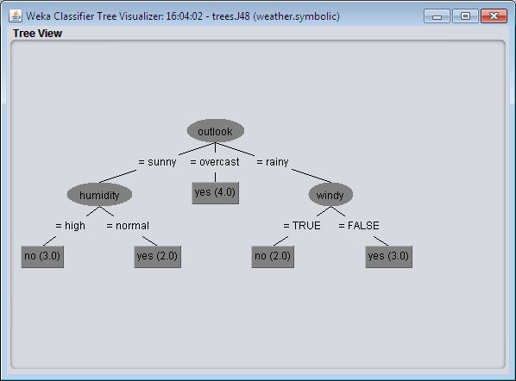

**STEPS:** (For **Knowledge Flow**)

Click **Knowledge Flow** in **Weka GUI Chooser**.



Draw **ArrfLoader** and select the **filename.**



To create the following and click **Run** button and Right click the **TextViwer** and select **Show Result.**

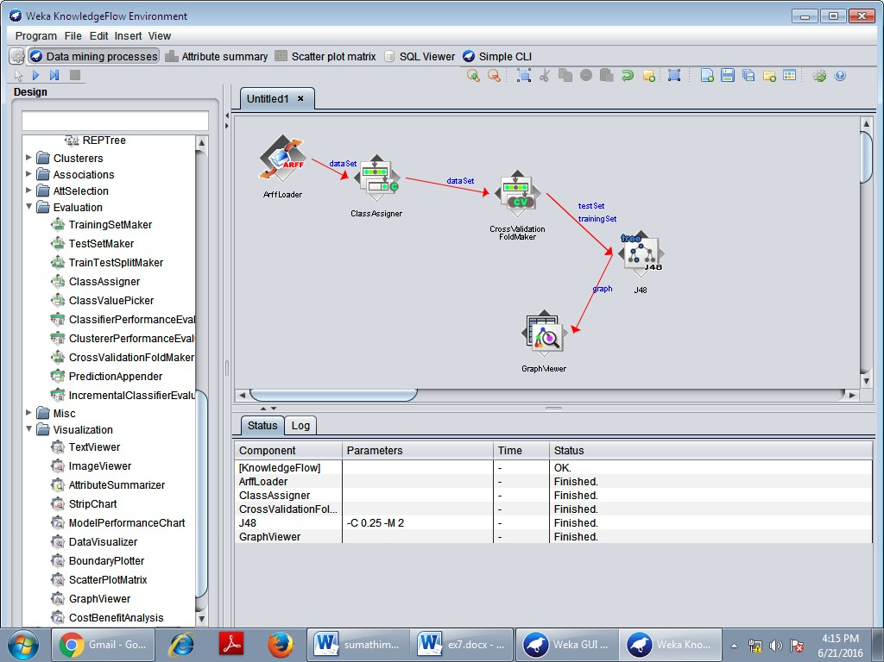

Right click **GraphViewer** – click **Show Plots**.

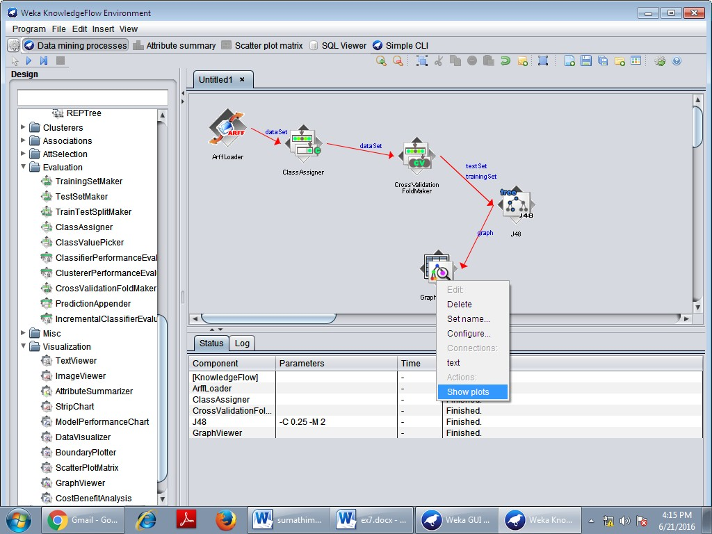

# OUTPUT:

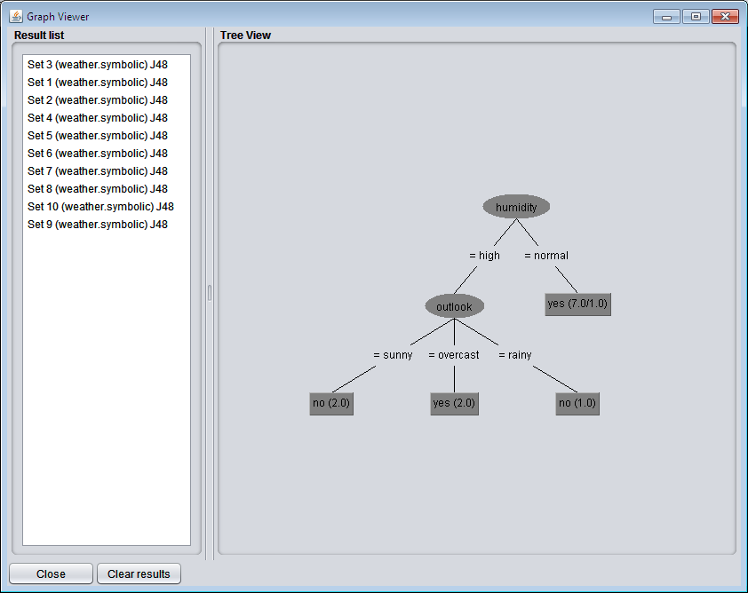Decision Tree

|  |  |
| --- | --- |
| **Ex no: 8 Date:** | **SUPPORT VECTOR MACHINES** |

**AIM:**

This experiment illustrates the use of Support vector classifier in weka. The sample data

set used in this experiment is vote dataset available in arff format. This document assumes that appropriate data preprocessing has been performed.

# SUPPORT VECTOR MACHINES

Support Vector Machines (SVMs) are supervised learning methods used for classification and regression tasks that originated from statistical learning theory as a classification method, SVM is a global classification model that generates non-overlapping partitions and usually employs all attributes. The entity space is partitioned in a single pass, so that flat and linear partitions are generated. SVMs are based on maximum margin linear discriminates, and are similar to probabilistic approaches, but do not consider the dependencies among attributes.

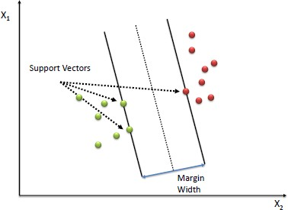

# SVM—History and Applications

* + Vapnik and colleagues (1992)—groundwork from Vapnik & Chervonenkis‘statistical learning theory in 1960s.
  + Features: training can be slow but accuracy is high owing to their ability to model complex nonlinear decision boundaries (margin maximization).
  + Used both for classification and prediction.
  + Applications: handwritten digit recognition, object recognition, speaker identification, benchmarking time-series prediction tests.

# Algorithm

* + Define an optimal hyper plane: maximize margin
  + Extend the above definition for non-linearly separable problems: have a penalty term for misclassifications.
  + Map data to high dimensional space where it is easier to classify with linear decision surfaces: reformulate problem so that data is mapped implicitly to this space.

# PROCEDURE:

1. We begin the experiment by loading the data (vote.arff) into weka.
2. Next we select the classify tab and click choose function button to select the Support vector machine (SMO).
3. Now we specify the various parameters. These can be specified by clicking in the text box to the right of the chose button.
4. Under the “text “options in the main panel. We select the 10-fold cross validation as our evaluation approach. Since we don’t have separate evaluation data set, this is necessary to get a reasonable idea of accuracy of generated model.
5. We now click ”start” to generate the model .the ASCII version of the tree as well as evaluation statistic will appear in the right panel when the model construction is complete.
6. Note that the classification accuracy of model is about 69%.this indicates that we may find more work. (Either in preprocessing or in selecting current parameters for the classification)
7. The run information of the support vector classifier will be displayed with the correctly and incorrectly classified instances.

# STEPS:

Open **Weka** tool – click **Explorer** in **Weka GUI Chooser**.

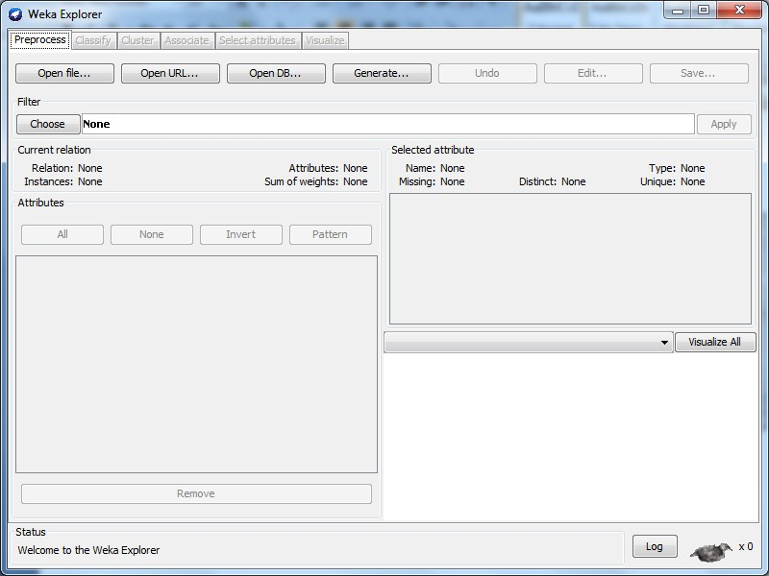

In **preprocess** tab click **Open file.. –** choose **file name** (vote.arff).

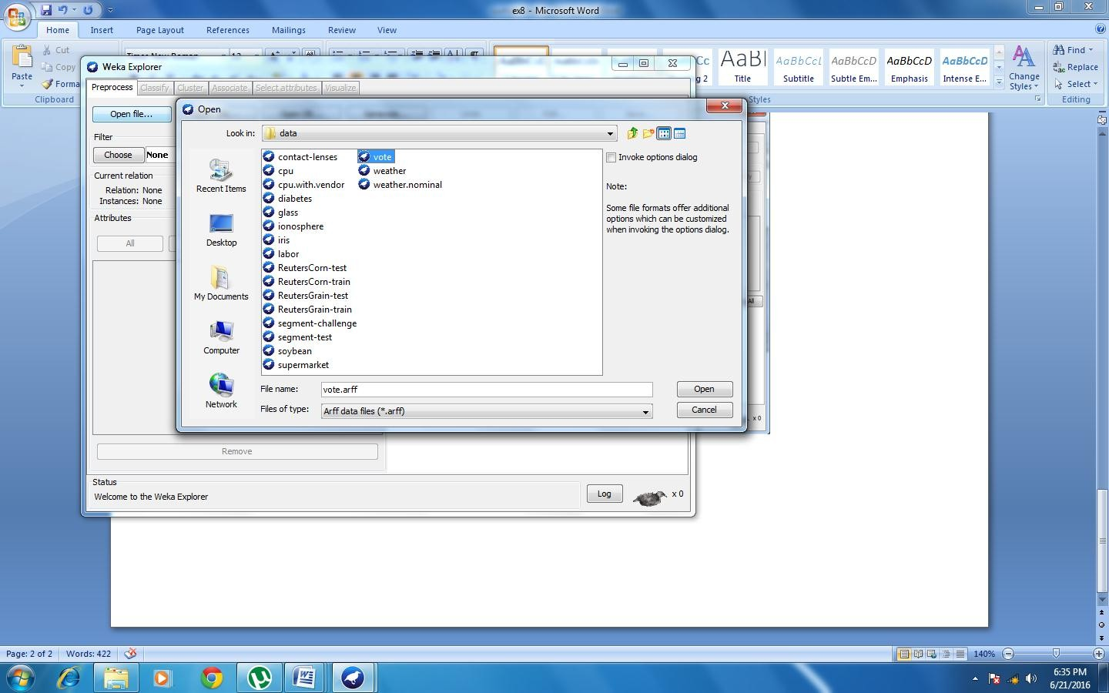

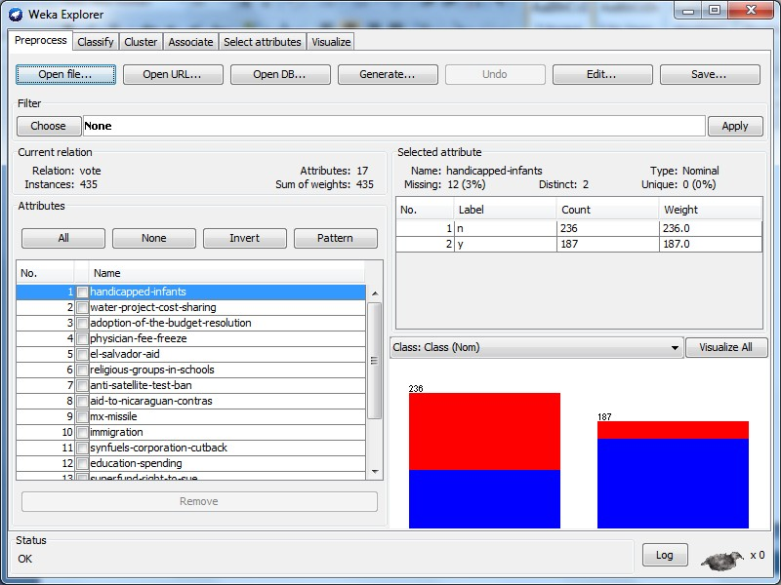

Goto **Classify** tab - click **Choose** button – select **SMO** option.

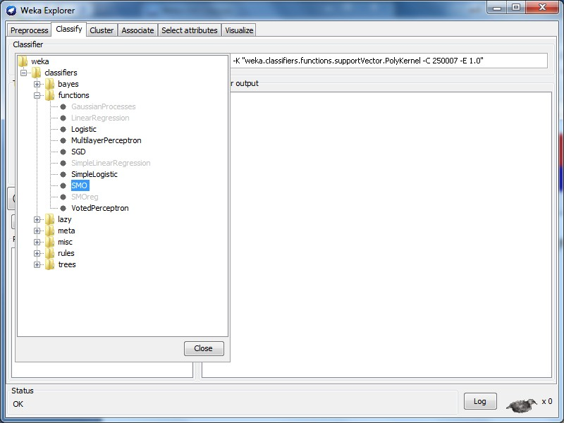

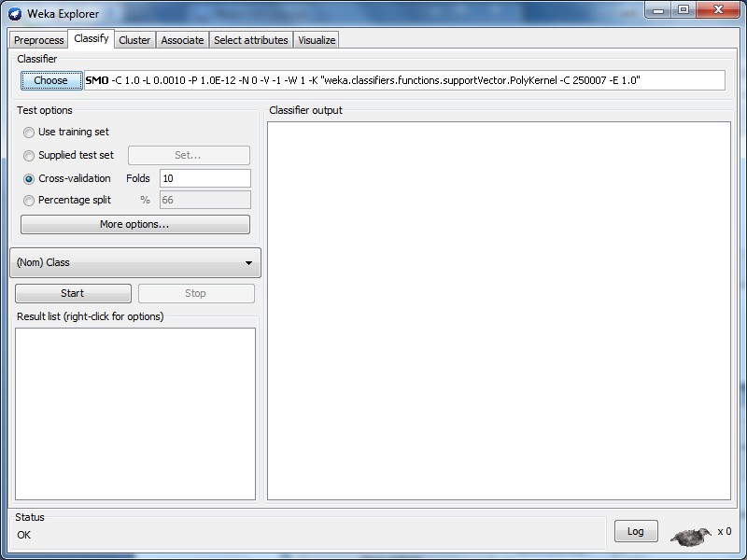

Click **Start** button.

# OUTPUT:

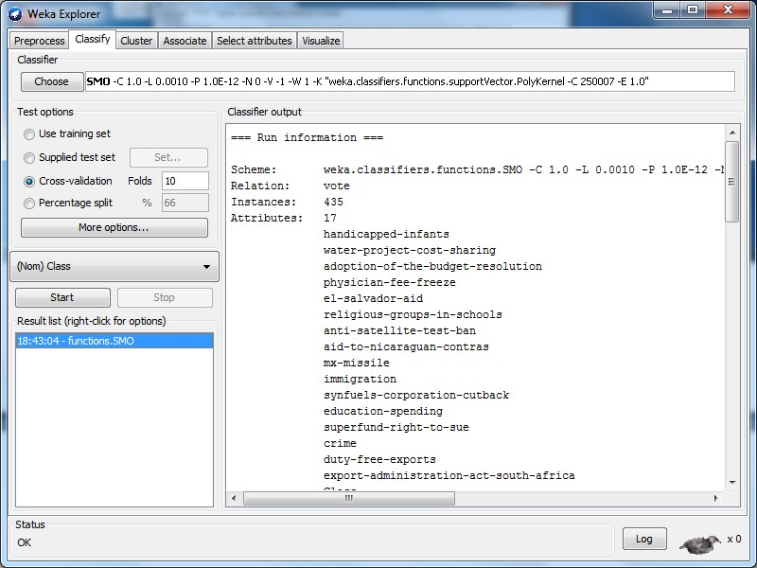

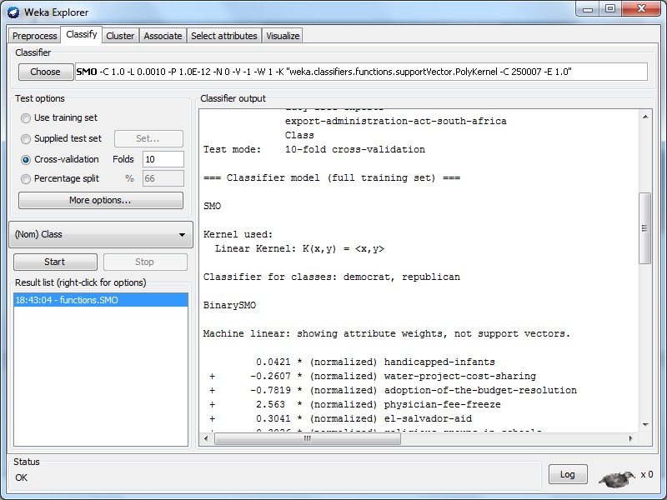

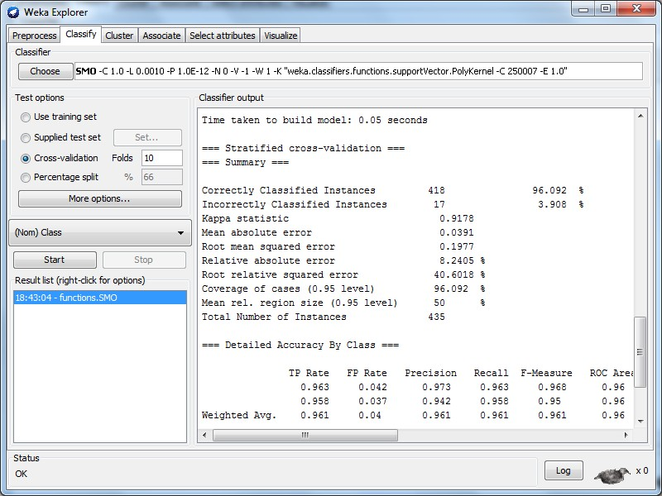

|  |  |
| --- | --- |
| **Ex no: 9 Date:** | **APPLICATIONS OF CLASSIFICATION FOR WEB MINING** |

**AIM**

To analyze an application using weka tool.

# WEB MINING

Use of data mining techniques to automatically discover interesting and potentially useful information from Web documents and services.

# Web mining may be divided into three categories.

* + Web content mining.
  + Web structure mining.
  + Web usage mining.

Web mining is the application of data mining techniques to extract knowledge from web data, i.e. web content, web structure, and web usage data.

# WEB CONTENT MINING

Web content mining is the process of extracting useful information from the contents of web documents. Content data is the collection of facts a web page is designed to contain. It may consist of text, images, audio, video, or structured records such as lists and tables. Application of text mining to web content has been the most widely researched. Issues addressed in text mining include topic discovery and tracking, extracting association patterns, clustering of web documents and classification of web pages. Research activities on this topic have drawn heavily on techniques developed in other disciplines such as Information Retrieval (IR) and Natural Language Processing (NLP). While there exists a significant body of work in extracting knowledge from images in the fields of image processing and computer vision, the application of these techniques to web content mining has been limited.

# WEB STRUCTURE MINING

The structure of a typical web graph consists of web pages as nodes, and hyperlinks as edges connecting related pages. Web structure mining is the process of discovering structure information from the web. This can be further divided into two kinds based on the kind of structure information used.

|  |  |
| --- | --- |
| **Ex no: 10 Date:** | **CASE STUDY ON TEXT MINING** |

**AIM:**

To perform the text mining using Weka tool.

# What is text mining?

* Data mining in text: find something useful and surprising from a text collection.
* Text mining vs. information retrieval.
* Data mining vs. database queries.

# Types of text mining

* + Keyword (or term) based association analysis.
  + Automatic document (topic) classification similarity detection.
  + Cluster documents by a common author.
  + Cluster documents containing information from a common source.
  + Sequence analysis: predicting a recurring event, discovering trends.
  + Anomaly detection: find information that violates usual patterns.
  + Discovery of frequent phrases.
  + Text segmentation (into logical chunks).
  + Event detection and tracking.

# Information Retrieval

Information retrieval deals with the retrieval of information from a large number of text- based documents. Some of the database systems are not usually present in information retrieval systems because both handle different kinds of data. Examples of information retrieval system include.

* Online Library catalogue system.
* Online Document Management Systems.
* Web Search Systems etc.

The main problem in an information retrieval system is to locate relevant documents in a document collection based on a user's query. This kind of user's query consists of some keywords describing an information need.

In such search problems, the user takes an initiative to pull relevant information out from a collection. This is appropriate when the user has ad-hoc information need, i.e., a short-term need. But if the user has a long-term information need, then the retrieval system can also take an initiative to push any newly arrived information item to the user.

This kind of access to information is called Information Filtering. And the corresponding systems are known as Filtering Systems or Recommender Systems.

# Basic Measures for Text Retrieval

We need to check the accuracy of a system when it retrieves a number of documents on the basis of user's input. Let the set of documents relevant to a query be denoted as {Relevant}

and the set of retrieved document as {Retrieved}. The set of documents that are relevant and retrieved can be denoted as {Relevant} ∩ {Retrieved}. This can be shown in the form of a Venn diagram as follows

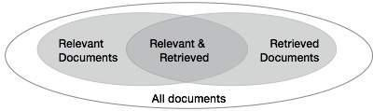

There are three fundamental measures for assessing the quality of text retrieval

* Precision
* Recall
* F-score

# PRECISION

Precision is the percentage of retrieved documents that are in fact relevant to the query.

Precision can be defined as

# Precision= |{Relevant} ∩ {Retrieved}| / |{Retrieved}|

**RECALL**

Recall is the percentage of documents that are relevant to the query and were in fact retrieved. Recall is defined as

# Recall = |{Relevant} ∩ {Retrieved}| / |{Relevant}|

**F-SCORE**

F-score is the commonly used trade-off. The information retrieval system often needs to trade-off for precision or vice versa. F-score is defined as harmonic mean of recall or precision as follows

# F-score = recall x precision / (recall + precision) / 2

**SAMPLE EXERCISE**

**Spam.arff**

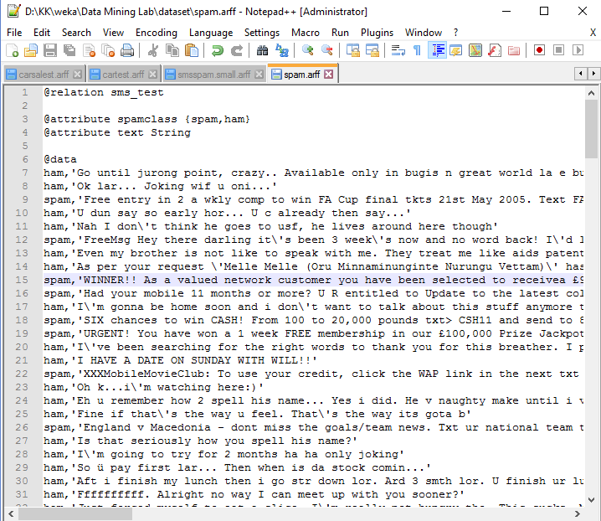

**Open** the file **spam.arff**

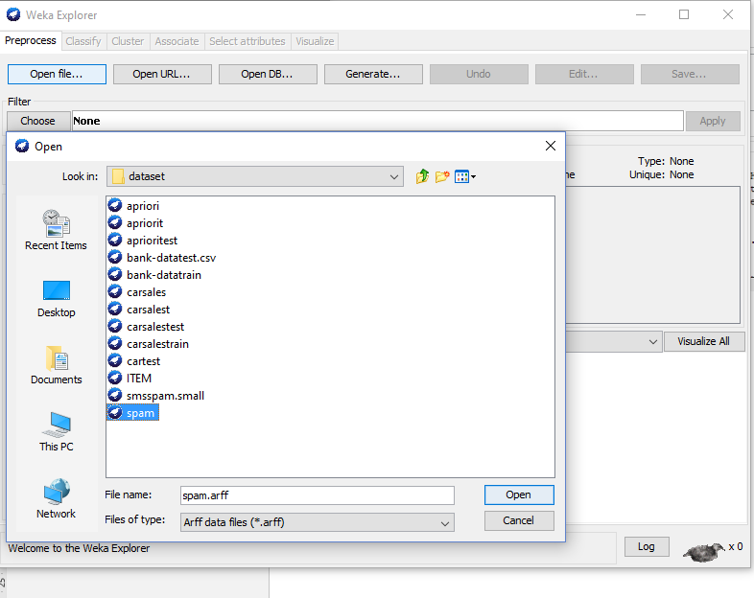

# Choose Filter -> unsupervised->attributebased->StringToWordVector

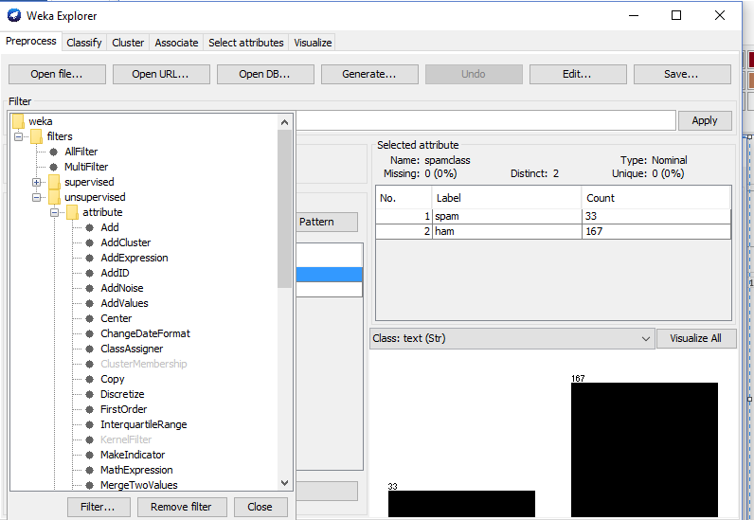

**Choose StringToWordVector**

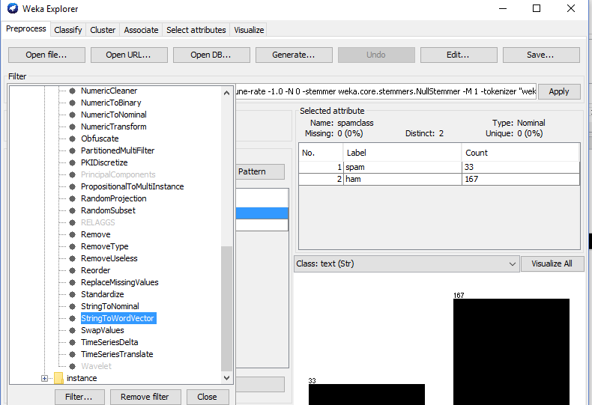

**Choose the attributes for filter**

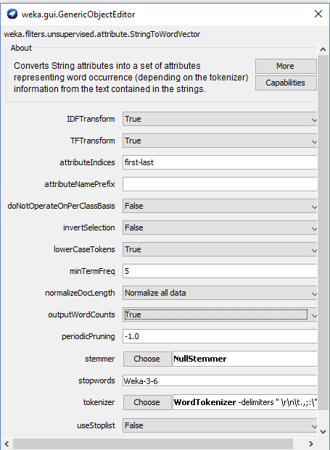

**Choose Edit -> Select Attribute as class**

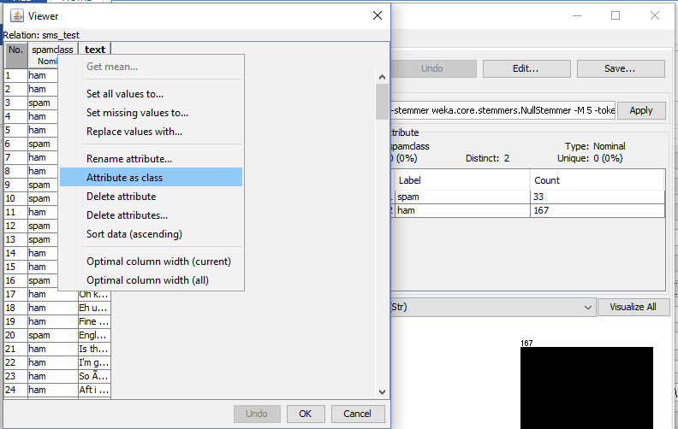

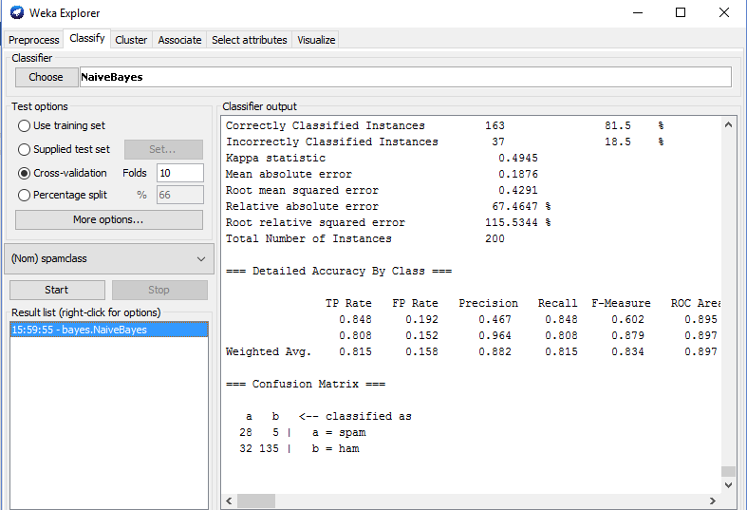**Choose Classify ->Naïve Bayes**

Click **Start** button.

# OUTPUT:

